Annual Compliance Report 1 (Nov 2023) – Rockhampton Ring Road
EPBC Approval 2020/8286
November 2022 – November 2023

Copyright
This publication is protected by the Copyright Act 1968.
© The State of Queensland (Department of Transport and Main Roads) 2023. All rights reserved.

No part of this document may be reproduced by any process, electronic or otherwise, in any material form or transmitted to any other person or stored electronically in any form, without prior written permission of the copyright holder, except as permitted under the Copyright Act 1968 (Cth).

Disclaimer
This publication is provided as a source of information only and the State of Queensland makes no statements, representations or warranties about its accuracy or completeness. To the extent permitted by law, the State of Queensland disclaims all responsibility for decisions or actions taken as a result of any data, information, statement or advice, expressed or implied, contained within and excludes all liability (including, without limitation, liability in negligence) for all expenses, losses, damages and costs that may be incurred.

Departmental approvals

Date | Name | Position | Action required  (Review/endorse/approve)

05/01/2024 Eddie Ohl Project Manager (Construction (Rockhampton Ring Road))
Endorsed

Risk level
- GACC major ☐ GACC minor ☒ High risk (but not GACC) ☐ Medium risk

Prepared by Title  District & Region Branch & Division  Project/program Project number Project location Status  DMS ref. no. | Cheryl Ward
 | Senior Environmental Officer
 | Fitzroy District / Central Queensland Region
 | Program Delivery & Operations/ Infrastructure Management and Delivery Divisions
 | Rockhampton Ring Road
 | 1167108
 | Rockhampton
 | Draft
 | 450/00973 E 304381 - PDO

Proponent and Approval Action

Detail | Applicable details
EPBC Reference Number: Project name:  Proponent: ABN:  Proposed action:  Location of action:  Reporting period: Date prepared: | EPBC 2020/8628
 | Rockhampton Ring Road
 | Department of Transport and Main Roads
 | 39 407 690 291
 | To construct a highway standard ring road and associated infrastructure, within the Rockhampton Region, Queensland
 | Rockhampton
 | November 2022- November 2023
 | January 2024

Declaration of Accuracy
In making this declaration, I am aware that sections 490 and 491 of the Environment Protection and Biodiversity Conservation Act 1999 (Cth) (EPBC Act) make it an offence in certain circumstances to knowingly provide false or misleading information or documents. The offence is punishable on conviction by imprisonment or a fine, or both. I declare that all the information and documentation supporting this compliance report is true and correct in every particular. I am authorised to bind the approval holder to this declaration and that I have no knowledge of that authorisation being revoked at the time of making this declaration.

Signed

Full name Peter Trim

Position Project Director (Rockhampton Ring Road)

Organisation Department of Transport and Main Roads (ABN 39 407 690 291)

Date 08/01/2024

Table of contents
Departmental approvals | 3
Risk level | 3
1. Introduction | 1
1.1. Purpose of this report | 1
1.2. Matters of National Environmental Significance | 1
2. Description of Activity | 3
2.1. Project Location | 3
2.2. Description of the Project | 3
2.3. Project Progress | 5
2.4. Approval History | 5
3. Compliance with Conditions | 5
4. Conclusion | 15

Table 1: Relevant Dates for EPBC Act Approval 5
Table 2: Chronology of Compliance Reports 5
Table 3: Summary of compliance with EPBC Act Approval Conditions 6
Appendix 1 - RRR North Package Disturbance 16
Appendix 2 - RRR South Package Disturbance 17

- Introduction

  - Purpose of this report
The Department of Transport and Main Roads (TMR) is constructing a western road link off the Bruce Highway to the west of Rockhampton, Alexandra Street and Yaamba Road (Rockhmapton – Yepppoon Road). The Rockhampton Ring Road (RRR) Project will deliver 17.4 km of new roadway incorporating 18 bridges totalling 6km in length. This includes 14.7 km of new roadway for the Bruce Highway to the west of Rockhampton at a 1% Annual Exceedance Probability (AEP) flood immune level for a flood free route between the town of Gracemere and the Rockhampton suburb of Parkhurst. The new roadway comprises a two-lane highway, from a new intersection with the Capricorn Highway, north to the intersection with the new West Rockhampton Connector Road, expanding to a four-lane highway to the intersection with the Rockhampton - Yeppoon Road. Connectivity into Rockhampton is provided via the 2.4 km West Rockhampton Connector Road accessing the Central Queensland Regional infrastructure of the Rockhampton Airport and Rockhampton Base Hospital.
The Project was referred to the Department of Climate Change, Energy, the Environment and Water (DCCEEW) in November 2021 for determination of whether the Project was likely to have a significant impact on Matters of National Environmental Significance (MNES). Projects likely to cause a significant impact on MNES require approval under the Environmental Protection and Biodiversity Conservation Act 1999 (EPBC Act). The Project was deemed a controlled action in June 2020 and was approved, subject to conditions, on 24th of August 2022.
Condition 17 of the EPBC Act approval requires that TMR prepare and publish an annual compliance report on its website, that addresses compliance with each of the conditions of the approval for each 12-month period following the date of construction commencement. This report is the 1st annual compliance report for the Project for the period November 2022 to November 2023.

  - Matters of National Environmental Significance
Under the EPBC Act, a project must be referred for actions that are likely to have a significant impact on matters protected under Chapter 2 of the EPBC Act. These are known as controlling provisions. This Project triggered 2 controlling provision/s: listed threatened species and communities (Section 18 and Section 18A) and list migratory species (Sections 20 and 20A). The action was assessed as having the potential to impact on the following matters protected by the EPBC Act:

    - Flora
      - Brigalow (Acacia harpophylla dominant and co-dominant) threatened ecological community (TEC) – Endangered
      - Black Ironbox (Eucalyptus raveretiana)- Vulnerable

    - Aquatic Fauna
      - Estuarine Crocodile (Crocodylus porosus) – Migratory, Marine
      - The Fitzroy River Turtle (Rheodytes leukops) – Vulnerable
      - White-throated Snapping Turtle (Elseya albagula) – Critically endangered

    - Terrestrial Fauna
      - Australian Painted Snipe (Rostratula australis) – Endangered
      - Grey-headed Flying-fox (Pteropus poliocephalus) – Vulnerable

      - Koala (Phascolarctos cinereus) (combined populations of Queensland, New South Wales andthe Australian Capital Territory) – Vulnerable
      - Ornamental Snake (Denisonia maculata) – Vulnerable
      - Squatter Pigeon (Geophaps scripta scripta) – Vulnerable

    - Migratory Birds
      - Latham’s Snipe (Gallinago hardwickii) – Migratory, Marine
      - Other Migratory – listed birds
        - Black-tailed godwit
        - Curlew sandpiper
        - Little curlew
        - Marsh sandpiper
        - Red-necked stint
        - Sharp-tailed sandpiper.

- Description of Activity

  - Project Location
The Rockhampton Ring Road (RRR) project commences at the Capricorn Highway approximately 2km west of the interstation of the Bruce and Capricorn highways (Yeppoon Roundabout) and its alignment traverses north through the Western Yeppoon Floodplain, sweeping around the Rockhampton Airport and Pink Lily and connecting to West Rockhampton near Rockhampton Ridgelands - Road before crossing the Fitzroy River north of Limestone Creek. After crossing the Fitzroy River, the RR intersections Alexandra Street in Parkhurst and connects with the Bruce Highway at the Yaamba Road and Rockhampton – Yeppoon Road intersection.
The total combined length of the Project is approximately 17 km (including the West Rockhampton Connector). The length of the Project from the Capricorn Highway intersection to the Yeppoon Road intersection is approximately 14.7km (excluding the West Rockhampton Connector.

  - Description of the Project
The Rockhampton Ring Road (RRR) Project will deliver 17.4 km of new roadway incorporating 18 bridges totalling 6km in length. This includes 14.7 km of new roadway for the Bruce Highway to the west of Rockhampton at a 1% Annual Exceedance Probability (AEP) flood immune level for a flood free route between the town of Gracemere and the Rockhampton suburb of Parkhurst. The new roadway comprises a two-lane highway, from a new intersection with the Capricorn Highway, north to the intersection with the new West Rockhampton Connector Road, expanding to a four-lane highway to the intersection with the Rockhampton - Yeppoon Road. Connectivity into Rockhampton is provided via the 2.4 km West Rockhampton Connector Road accessing the Central Queensland Regional infrastructure of the Rockhampton Airport and Rockhampton Base Hospital.
A package of work grouped into North and South locations has been developed as follows: North Package 1:
- Construct the ring road section between the Bruce Highway /Rockhampton–Yeppoon Road intersection
and Monier Road embankment, including a crossing of Limestone Creek.
- Works required for the realigned Boundary Road, McLaughlin Street, existing Boundary Road, and Monier Road access.
- Construct accesses for Dreamtime Cultural Centre, Queensland Ambulance Service and Queensland Fire and Emergency Services precinct.
South Package 1:
- Rockhampton–Ridgelands Road upgrade including Canoona Road intersection, replacement of Lion Creek bridge, modifications to Osborne Road, and construction of the Ridgelands Road–Osborne Road roundabout with a stub for future connection to the ring road.
- Upgrade of Nine Mile Road/Rockhampton–Ridgelands Road intersection.
- Preload of embankment between the Capricorn Highway and Abutment A of Bridge BR04 (over soft soils).

Figure 1 provides an overview of the project area.

Figure 1 Rockhampton Ring Road North and South Packages
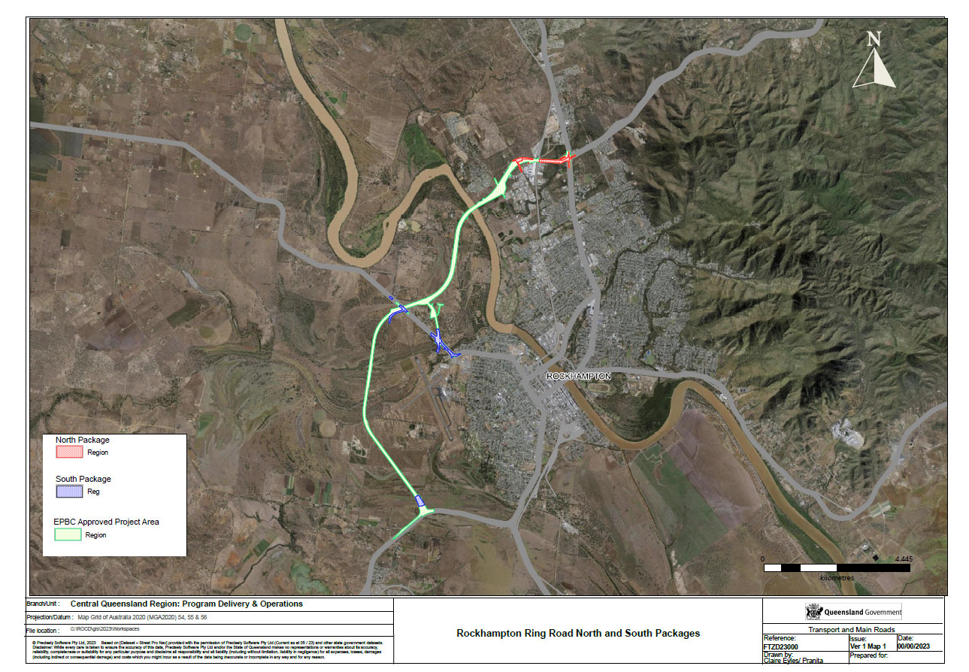

Annual Compliance Report 1 (Nov 2023) – Rockhampton Ring Road – EPBC Approval 2020/8286 - 4 -

  - Project Progress
A package of work grouped into North and South locations sites has been developed and construction is underway.
Civil works commenced in October 2023, with compound establishment and site team mobilised to site in November 2023 for both north and south packages.
Clearing commenced in November 2023.
Additionally, the project intersects with Stanwell-Gladstone Infrastructure Corridor State Development Area with an average width of 100m. Areas within this corridor have been cleared as part of other projects or preparation for relocation of services for Rockhampton Ring Road project.

  - Approval History
The date of the EPBC Act approval, and the compliance reporting dates and status of the annual compliance reports, are provided in Tables 1 and 2.

Table 1: Relevant Dates for EPBC Act Approval

Approval number | Date of decision | Expiry date
2020/8628 24/08/2022 |  | 31 December 2032
Table 2: Chronology of Compliance Reports
Reporting dates | Report No. | Status
Nov 22 – Nov 23 1 |  | Completed and published

- Compliance with Conditions
Table 3 provides an overview of the conditions and compliance status. Where additional information is required, reference has been made to relevant sections of this report for further evidence of compliance.

Annual Compliance Report 1 (Nov 2023) – Rockhampton Ring Road – EPBC Approval
2020/8286 - 5 -

Table 3: Summary of compliance with EPBC Act Approval Conditions

Condition Number. | Condition | Is the project compliant with this condition? | Summary of compliance
1 | To minimise impacts on protected matters, the approval holder must not clear outside of the project area. | Compliant | Disturbance within project area commenced in November 2023 with a total of 8.50 ha in South Package 1 section and 2.04 ha in the North Package 2 section, for a total of 10.54 ha as shown in Appendix 1 and Appendix 2. There was minor clearance outside of the project area (approximately 0.02 ha) but no areas of protected matters were impacted.
 |  |  | A disturbance permit process has been implemented to assess areas outside of project area prior to disturbance to ensure no protected matters are impacted outside of the approved area.
 |  |  | Area has also been cleared in the project area that intersects with the Stanwell-Gladstone Infrastructure Corridor State Development Area which is a 90 km corridor with and average width of 100m.
2 | For the protection of protected matters during clearance, the approval holder must ensure that a fauna spotter/catcher supervises all clearing activities and is given sufficient authority to ensure that such activities do not cause injury or death of animal protected matters,  including authority to cease clearing where one or more animal protected matters may be impacted. | Compliant | A fauna spotter/catcher supervised all clearing and no animal protected matters was found.
3 | To avoid and mitigate impacts on protected matters, the approval holder must implement the Environmental management plan until the completion of the action. | Compliant | Rockhampton Ring Road Environmental Management Plan (Nov 2021) was submitted as part of application process and subsequent plans have been developed by the contractors for South Package 1 and North Package 2 for the project.
4 | To avoid impacts on protected matters, the approval holder must ensure water for construction works is not sourced from wetlands. | Compliant | No water has been sourced from wetlands.
5 |  | Compliant | Water related discharges are directed into drainage lines a.

Condition Number. | Condition | Is the project compliant with this condition? | Summary of compliance
The approval holder must ensure drainage lines are configured such that during the construction process construction-related water discharge is always directed into sediment controls in accordance with the
Environmental management plan.
6 | The approval holder must capture runoff in sediment basins and ensure that:  - captured water is only released to the receiving environment where within the water quality criteria (discharge);  - there is no direct discharge to wetlands; and  - outlets from sediment basins are designed to direct discharge away from wetlands. | Compliant | Sediment basins had not been constructed in this reporting period.
7 | If dewatering is undertaken during construction, the approval holder must:  - for works in the Fitzroy River, return abstracted water to the Fitzroy River only if water quality criteria (waterway and wetland) are achieved; and  - for works outside the Fitzroy River, capture abstracted water in sediment basins and only release to the receiving environment if water quality criteria (discharge) are achieved or, if to be released to land, only where the water quality criteria (dewatering to land) are achieved. | Compliant | No dewatering was completed during this reporting period.
8 | Following construction, the approval holder must actively rehabilitate all rehabilitation areas to reinstate the pre-disturbance vegetation community, using  endemic native species appropriate to their position in | NA | Construction incomplete.

Condition Number. | Condition | Is the project compliant with this condition? | Summary of compliance
 | the landscape and in accordance with the MRTS16 Technical Specification.
9 | To ensure the establishment and long-term sustainability of rehabilitated areas in accordance with condition 8, the approval holder must:  - ensure rehabilitated areas achieve the completion criteria within 12 months of completion of the action; and  - monitor rehabilitated areas to ensure completion criteria, once met, are maintained for a further minimum of 12 months. | NA | Construction incomplete
10 | At the first annual compliance report following the achievement of the completion criteria, the approval holder must submit a report to the department that demonstrates that the entirety of the rehabilitation areas have fully achieved and maintained the completion criteria in accordance with conditions 8 and 9. | NA | Construction incomplete.
11 | The approval holder must notify the department in writing of the date of commencement of the action within 10 business days after the date of commencement of  the action. | Compliant | Email sent to advise of commencement of the action on the 5th of November 2022.
12 | If the commencement of the action does not occur within 5 years from the date of this approval, then the approval  holder must not commence the action without the prior written agreement of the Minister. | Compliant | Date of approval is 24/8/22 and action commenced within 5 years of this date.
13 | The approval holder must maintain accurate and complete compliance records. | Compliant | Records have been audited for accuracy during weekly inspections and during 6 monthly audits.

Condition Number. | Condition | Is the project compliant with this condition? | Summary of compliance
14 | If the department makes a request in writing, the approval holder must provide electronic copies of compliance records to the department within the  timeframe specified in the request. | Compliant | No records requested.
15 | The approval holder must:  a. submit plans electronically to the department for approval by the Minister; | Non-Compliant | Rockhampton Ring Road Environmental Management Plan (Nov 2021) was not uploaded to the public website within the required time. The plan has since been uploaded at https://www.tmr.qld.gov.au/projects/rockhampton-ring-road
 | b. publish each plan on the website within 20 business days of the date the plan is approved by the Minister or of the date a revised action management plan is submitted to the Minister or the department, unless otherwise agreed to in writing by the Minister;
 | c. exclude or redact sensitive ecological data from plans published on the website or provided to a member of the public; and
 | d. keep plans published on the website until the end date of this approval.
16 | The approval holder must ensure that any monitoring data (including sensitive ecological data), surveys, maps, and other spatial and metadata required under a plan, is prepared in accordance with the department’s Guidelines for biological survey and mapped data (2018) and submitted electronically to the department in  accordance with the requirements of the plan. | Compliant | NA – no plans are required as part of this approval.
17 | The approval holder must prepare a compliance report for each 12-month period following the date of | Compliant | Report completed and submitted and published at https://www.tmr.qld.gov.au/projects/rockhampton-ring-road
 | commencement of the action, or otherwise in
 | accordance with an annual date that has been agreed to
 | in writing by the Minister. The approval holder must:

Condition Number. | Condition | Is the project compliant with this condition? | Summary of compliance
- publish each compliance report on the website within 60 business days following the relevant 12-month period;
- notify the department by email that a compliance report has been published on the website and provide the weblink for the compliance report within 5 business days of the date of publication;
- keep all compliance reports publicly available on the website until this approval expires;
- exclude or redact sensitive ecological data from compliance reports published on the website; and
- where any sensitive ecological data has been excluded from the version published, submit the full compliance report to the department within 5 business days of publication.
18 | The approval holder must notify the department in writing of any incident. The notification must be given as soon as practicable, and no later than 2 business days after becoming aware of the incident. The notification must specify:  - a short description of the incident; and  - the location (including co-ordinates), date, and time of the incident. In the event the exact information cannot be provided, provide the best information available. | Compliant | Nil incidents have occurred which have impacted protected matters
19 | The approval holder must notify the department in writing of any non-compliance with the conditions or non-compliance with the commitments made in plans.  The notification must be given as soon as practicable, | Compliant | The department was notified in a meeting on 22/12/2023 and following clarification of condition 15 the department was formally 02/01/2023.

Condition Number. | Condition | Is the project compliant with this condition? | Summary of compliance
and no later than 2 business days after becoming aware of the non-compliance. The notification must specify:
- any condition which is or may be in breach;
- a short description of the non-compliance; and
- the location (including co-ordinates, if relevant), date, and time of the identified non-compliance. In the event the exact information cannot be provided, provide the best information available.
20 | The approval holder must provide to the department the details of any incident as soon as practicable and no later than 10 business days after becoming aware of the incident, specifying:  - any corrective action or investigation which the approval holder has already taken or intends to take in the immediate future;  - the potential impacts of the incident; and  - the method and timing of any remedial action that will be undertaken by the approval holder.  - where access to the site of the incident is unsafe for more than 5 business days (e.g. flood event), the approval holder must inform the department every 5 business days of the status of the incident until such time as actions identified in a) to c) have been complied.d. | Compliant | Nil incidents have occurred during this period.
21 | The approval holder must provide to the department the details of any non-compliance with the conditions or commitments made in plans as soon | Compliant | There have been no non-compliances during this period.

Condition Number. | Condition | Is the project compliant with this condition? | Summary of compliance
as practicable and no later than 10 business days after becoming aware of the incident, specifying:
- any corrective action or investigation which the approval holder has already taken or intends to take in the immediate future;
- the potential impacts of the non-compliance; and
- the method and timing of any remedial action that will be undertaken by the approval holder.
22 | The approval holder must ensure that independent audits of compliance with the conditions are conducted as requested in writing by the Minister. | Compliant | No audits have been requested by the Minister.
23 | For each independent audit, the approval holder must:  - provide the name and qualifications of the independent auditor and the draft audit criteria to the department;  - only commence the independent audit once the audit criteria have been approved in writing by the department; and  - submit an audit report to the department within the timeframe specified in the approved audit criteria. | Compliant | As above not independent audits have been requested.
24 | The approval holder must publish the audit report on the website within 10 business days of receiving the department’s approval of the audit report and keep the  audit report published on the website until the end date of this approval. | Compliant | As above no independent audits have been requested.
25 | The approval holder may, at any time, apply to the Minister for a variation to a plan approved by the | Compliant | As above no independent audits have been requested.

Condition Number. | Condition | Is the project compliant with this condition? | Summary of compliance
Minister by submitting an application in accordance with the requirements of section 143A of the EPBC Act. If the Minister approves a revised plan, then, from the date specified, the approval holder must implement the
revised plan in place of the previous plan.
26 | The approval holder may choose to revise a plan approved by the Minister under condition 3, or as subsequently revised in accordance with these conditions, without submitting it for approval under section 143A of the EPBC Act, if the taking of the action  in accordance with the plan would not be likely to have a new or increased impact. | Compliant | Project scope has remained as per submission – there is no new or increased impact.
27 | If the approval holder makes the choice under condition 26 to revise a plan without submitting it for approval, the approval holder must:  a. notify the department in writing that the approved plan has been revised and provide the department with:  - an electronic copy of the revised plan;  - an electronic copy of the revised plan marked up with track changes to show the differences between the approved plan and the revised plan;  an explanation of the differences between the approved plan and the revised plan;  - the reasons the approval holder considers that taking the action in accordance with the revised plan would not be likely to have a new or increased impact; and  - written notice of the date on which the approval holder will implement the revised plan (revised plan  implementation date), being at least 20 business days | Compliant | No plans are required as part of this approval.

Condition Number. | Condition | Is the project compliant with this condition? | Summary of compliance
after the date of providing notice of the revision of the plan, or a date agreed to in writing with the department.
b. subject to condition 27, implement the revised plan from the revised plan implementation date.
28 | The approval holder may revoke their choice to implement a revised plan under condition 26 at any time by giving written notice to the department. If the approval holder revokes the choice under condition 26, the approval holder must implement the plan in force immediately prior to the revision undertaken under  condition 27. | Compliant | No plans are required as part of this approval.
29 | If the Minister gives a notice to the approval holder that the Minister is satisfied that the taking of the action in accordance with the revised plan would be likely to have a new or increased impact, then:  - condition 26 does not apply, or ceases to apply, in relation to the revised plan; and  - the approval holder must implement the plan specified by the Minister in the notice. | Compliant | No plans are required as part of this approval.
30 | At the time of giving the notice under condition 29, the Minister may also notify that for a specified period of  time, condition 26 does not apply for one or more specified plans. | Compliant | No plans are required as part of this approval.
31 | Within 20 business days after the completion of the action, or in any case at least 80 business days before the expiry of this approval, the approval holder must notify the department in writing of the status of the action and provide completion data. | Compliant | Project incomplete.

- Conclusion
Project has displayed general compliance with the conditions of the EPBC approval, noting that this is the 1st reporting year. Minor non-compliance is administrative only. Various contracts are in place to execute the commitments made in the approval and associated documents, and TMR anticipates ongoing compliance with the approval conditions.

Annual Compliance Report 1 (Nov 2023) – Rockhampton Ring Road – EPBC Approval
2020/8286 - 15 -

Appendix 1 - RRR North Package Disturbance
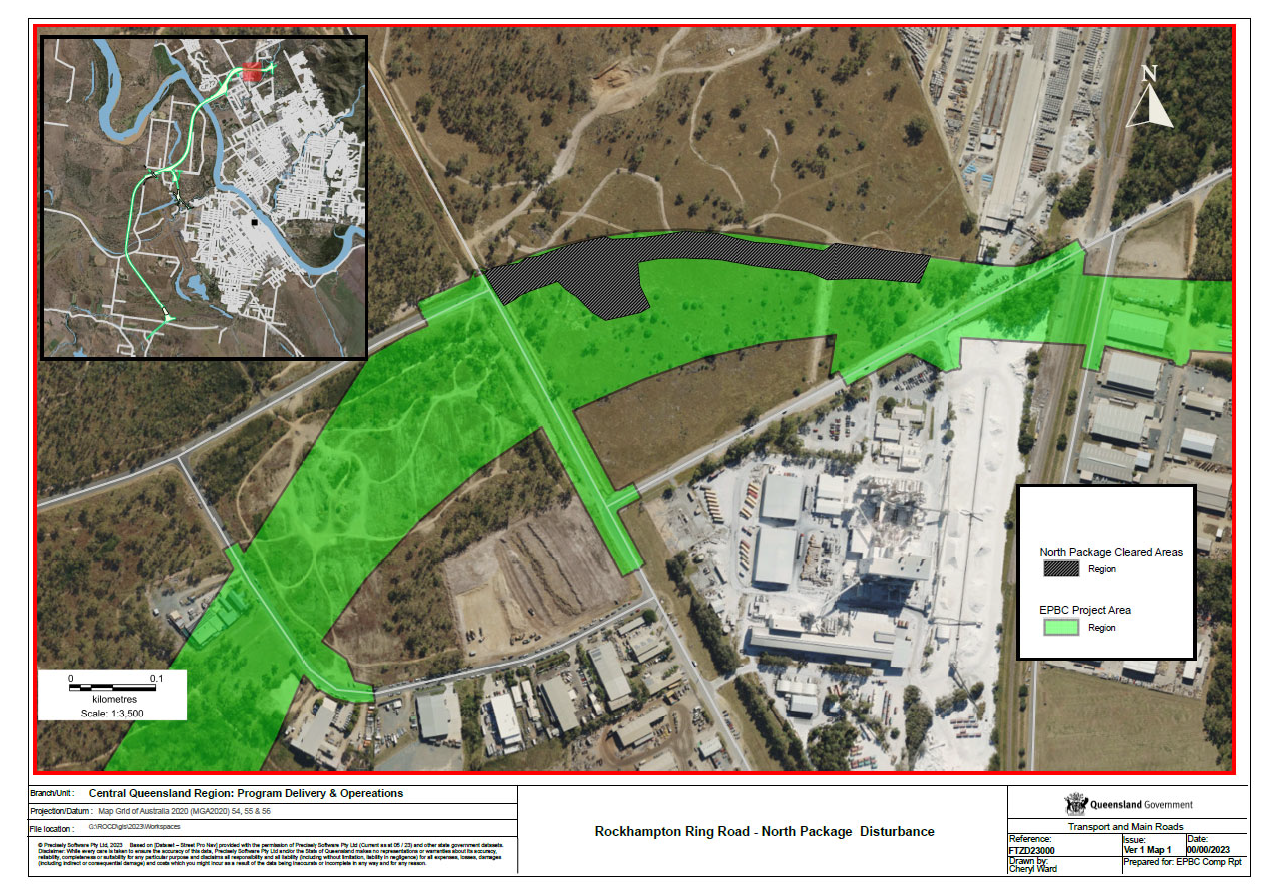

Appendix 2 - RRR South Package Disturbance
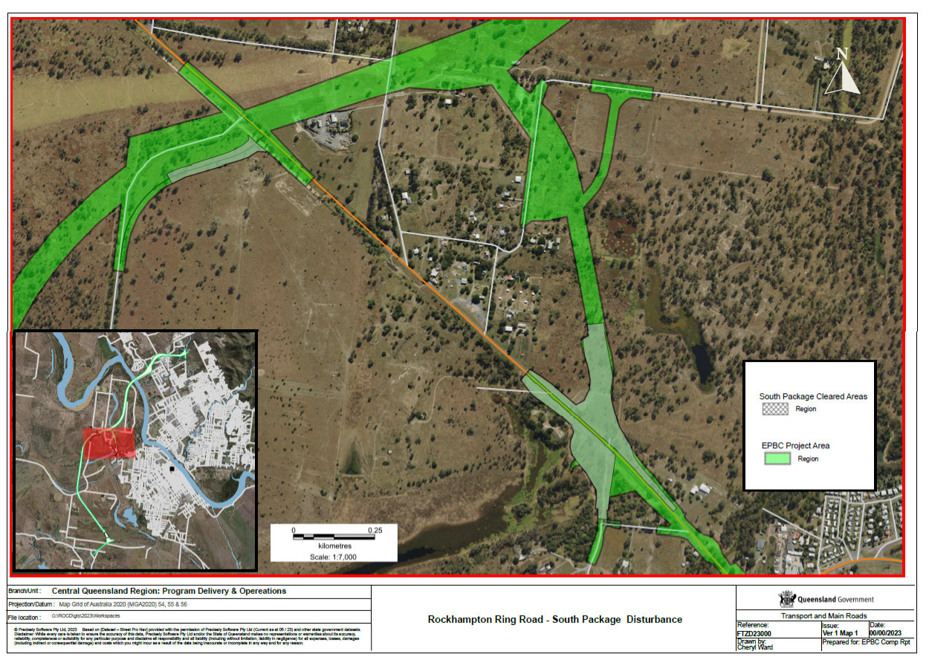

13 QGOV (13 74 68)
www.tmr.qld.gov.au I www.qld.gov.au

