Scarborough Boat Harbour Draft Master Plan 2023

Contents

Introduction
Master plan snapshot 4
Queensland’s maritime industry 7
Shaping the future of the Scarborough Boat Harbour 8
Approach and master plan objectives 10
What we heard 12
- Harbour context and setting 14
- Harbour infrastructure and operations 28
- Master plan and strategies 36
- Master plan design concepts 56
- Implementation 76

The Queensland Government is committed to providing accessible services to Queenslanders of all cultural and linguistic backgrounds. If you have difficulty understanding this publication and need a translator, please call the Translating and Interpreting Service (TIS National) on 131 450 and ask them to telephone the Department of Transport and Main Roads on 13 QGOV (13 74 68).
Contact us for alternative accessible formats.
Please email: bhplanning@tmr.qld.gov.au.
This information can also be found on our website:
https://www.tmr.qld.gov.au/projects/scarborough-boat-harbour

Copyright
© The State of Queensland (Department of Transport and Main Roads) 2023. All rights reserved.
Disclaimer
This publication is provided as a source of information only and the State of Queensland makes no statements, representations or warranties about its accuracy or completeness. To the extent permitted by law, the State of Queensland disclaims all responsibility for decisions or actions taken as a result of any data, information, statement or advice, expressed or implied, contained within and excludes all liability (including, without limitation, liability in negligence) for all expenses, losses, damages and costs that may be incurred.
Acknowledgement of Country
The Department of Transport and Main Roads (TMR) respectfully acknowledges the Traditional Owners and Custodians of the land and waterways. We pay respect to their Elders past, present and emerging. TMR recognises those whose ongoing effort to protect and promote Aboriginal and Torres Strait Islander cultures will leave a lasting legacy for future First Nation’s people.

Master plan snapshot

REALISING THE HARBOUR’S POTENTIAL
This master plan is a strategic decision-making tool offering greater certainty to government, investors, tenants and the community about the harbour’s future form and activity.
The master plan captures the broad opportunities presented by the boat harbour’s existing operations, place qualities and its role as a key centre of boating and leisure activity within Moreton Bay’s wider network of maritime and tourism infrastructure.
The goal is to sustainably address a growing maritime industry, engage the community, enhance the function and quality of the harbour and elevate the harbour’s recreation and tourism role in a manner that protects the important ecological values and processes of the Moreton Bay Marine Park and surrounds.
The master plan will guide future leasing and development decisions, working within
Queensland’s existing legislative and governance processes.
Master plan responses and outcomes for areas under the jurisdiction of the Moreton Bay City Council are indicative only to help illustrate potential harbour opportunities. They are subject to the processes and decision making of Moreton Bay City Council.
This concept master plan (opposite) illustrates strategies and ideas that have been generated through an integrated master planning process that engaged technical specialists, local and Queensland Government stakeholders, harbour tenants, volunteer groups and members of community.
Figure 1: Scarborough Boat Harbour Concept Master Plan
Notes:
- Master plan responses and outcomes for areas under the jurisdiction of the Moreton Bay City Council are indicative only to help illustrate potential harbour opportunities, and are subject to the Moreton Bay City Council processes and decision making.
- Trawler facilities will be retained in their current location until alternative locations / facilities are available.
- Boat ramp capacity in the harbour will be retained.
Figure 1 captions:
- New breakwater offering viewing and fishing opportunities
- New public boat ramp facility and car-trailer parking
- Scarborough Park widening and enhancement
- Maintain government services
- Park enhancement and improved connection
- Maintain public boat ramp and car-trailer parking area
- Marine activities
- Marine activities – low impact
- Waterfront walking and cycling path
- Landscape buffer to residential interface
- Magrove conservation
- Waterfront walking and cycling path upgrades
- Expanded marine activities
- Trawler facility, seafood processing and potential wholesale direct to public market space
- Extended wet lease opportunity
- Maintain existing structure of wet leases
- Dedicated berths for tourism operators and short term public berths
- Tourism, commercial and entertainment activities
- Mixed marine activities
- Streetscape enhancement and additional car parking
- Dedicated club and community facility for paddle craft groups
- Potential Thurecht Park enhancement and integration with wharf
- Enhanced public transport opportunities
- Jamieson Park integration and coastal walk connections
- Enhanced beach access and launch area for paddle craft
- Improved harbour entries and wayfinding signage

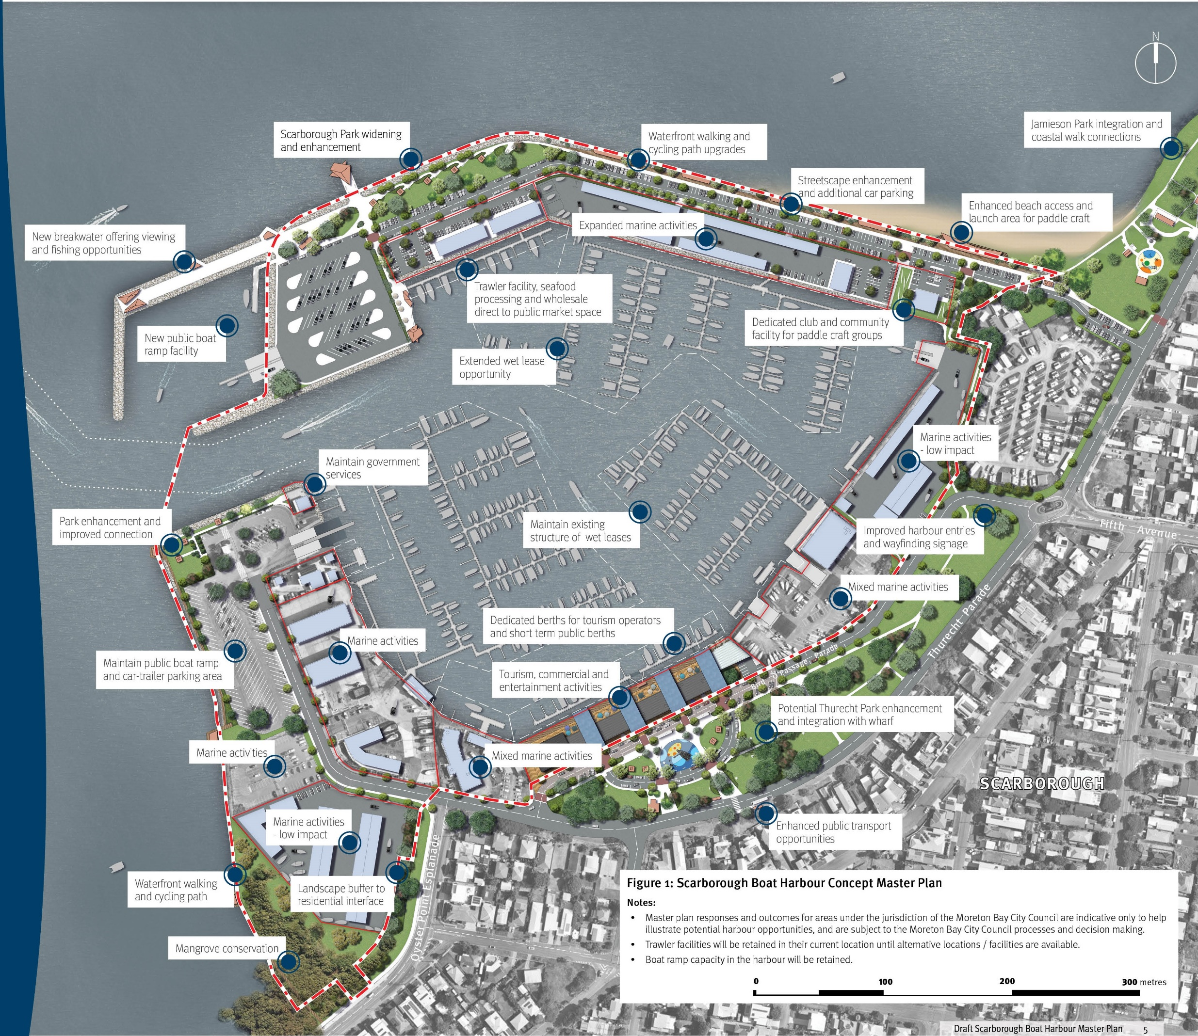
The core functions provided by Queensland’s state boat harbours are:
- Safe all-tide sheltered access
- Recreational public marine facilities including boat ramps, floating walkways, pontoons, public space and associated car-trailer parking
- Commercial businesses covering fishing, maritime industry, hospitality and tourism
- Marine community groups and clubs, marine rescue volunteer organisations
- Government services, maritime safety, boating and fisheries patrols, management of parks and wildlife, water police and emergency management.

TMR role and responsibilities for Queensland’s state boat harbours
Scarborough Boat Harbour is 1 of 8 state owned and managed boat harbours in Queensland. These were developed as part of a commitment by the Queensland Government in the 1960s and 1970s to promote boating activities along the Queensland coast. State boat harbours were initially established to provide all-tide sheltered boat launching and landing sites, and facilitate development of marinas and other commercial marine activities. The Department of Transport and Main Roads (TMR) through the Maritime Safety Queensland (MSQ) branch owns and manages the harbours including the public boating infrastructure (boat ramps, floating walkways, pontoons, jetties and breakwaters) within them.
TMR manages all land and seabed leases within each harbour to facilitate investment and development that supports a sustainable maritime industry and promotes local employment and tourism activities. TMR is responsible for maintaining the entrance and internal public navigation channels to the public boating facilities within each harbour. Lessees of seabed within the harbour precinct (such as marinas, commercial operators and boat clubs) are responsible for maintenance dredging within their leased areas.
Image captions:
- Bowen Boat Harbour
- Rosslyn Bay Boat Harbour
- Urangan Boat Harbour
- Snapper Creek Boat Harbour
- Mooloolaba Boat Harbour
- Scarborough Boat Harbour
- Cabbage Treet Creek Boat Harbour
- Manly Boat Harbour

Queensland’s maritime industry

A snapshot of growth to 2050
The maritime industry contributes over $8 billion to the Australian economy every year and the state boat harbours are significant contributors of the critical infrastructure that underpin the health and sustainable growth of the industry.
Reflecting global and national trends, Queensland’s maritime industry continues to experience sustained growth. Boating registrations and recreational vessel uptake have consistently increased over the last decade and this upward trend is forecast to continue.
This stimulates demand for more public boat ramp infrastructure, berthing and mooring infrastructure as well as supporting services such as commercial marinas, vessel maintenance and sales. A core function of state boat harbours is to cater for this growth.
There are also strong opportunities to strengthen the contribution of state boat harbours to our regional tourism economy. As a key gateway to Moreton Bay’s spectacular coastal waters and islands, Scarborough’s harbour will provide the vital infrastructure for the tourism businesses and operators tapping into a wide range of day cruise and eco-tourism markets.
Nationally, many of the larger metropolitan boat harbours offer a mix of tourism, entertainment and recreation activities and are popular destinations in their own right. At Scarborough, there are opportunities to build on existing infrastructure and commercial activities to enhance and broaden the harbour’s appeal for both the South East Queensland (SEQ) community and tourists.
In this context, it’s essential that we plan now for sustainable industry growth and deliver leadership in managing access to the internationally significant environments of Moreton Bay Marine Park.
- $8.8 billion turnover
- 27,630 employed directly
- Queensland has the highest domestic marine-based tourism output at $10.1 billion, 2017 – 2018
Source: The Australian Marine Industry 2020-2021

Shaping the future of the Scarborough Boat Harbour
This master plan establishes a flexible spatial framework to guide and manage harbour investment and development over a strategic timeframe to 2050. Once finalised, it will be a strategic decision-making tool offering greater certainty to government, investors, tenants and the community about the harbour’s future form and activity and support the sustainable growth of our region’s maritime industry.

A bold vision that looks to the long term
The growing recognition of state boat harbours as community, recreation and economic assets, as well as being the critical gateways to sustainably manage access to our internationally renowned coastal waterways and islands, increases the importance of planning for their future.
Harbours like Scarborough’s are capable of offering a broad range of complementary recreation, education, marine service and community functions and activities. However, harbour space is limited, so the type, location and mix of activities requires careful consideration to ensure the harbour is performing its primary functions for the maritime industry while inviting greater access for the community to experience the unique character of a working harbour and Moreton Bay’s expansive natural environments.
Compounding the challenges of limited space, both the public and commercial boating industries are growing, and this growth will inevitably place greater pressure on the Moreton Bay Marine Park. In coordination with the broader network of public and private marinas and boat ramp infrastructure, state boat harbours have a central role to play in the sustainable growth of the maritime industry and stewardship of the coastal environments.
These broad influences shaping the harbour’s future - protection of core harbour functions, maritime industry growth, greater public access and environmental sustainability - require a comprehensive, long term approach to master planning. Additionally, a complex layering
of local, state and federal legislation require extended timeframes to address the technical and planning requirements and length of assessment processes.
A flexible master plan framework is needed to inform ongoing decision-making and respond to the opportunities and challenges that arise as more detailed technical investigations and delivery of specific harbour interventions are undertaken.
The transition of the Scarborough Boat Harbour towards the master plan vision will ultimately be achieved through coordinated and staged improvements to the existing infrastructure and new development interventions over a long- term timeframe utilising existing legislative and leasing processes.

Quick facts
- TMR’s property at Scarborough Boat Harbour covers over 29 hectares of land and water area
- State boat harbours were developed as part of a commitment by the Queensland Government in the 1960s and 1970s to promote boating activities along the Queensland coast
- The Scarborough Boat Harbour was established in 1960, with first stages completed in 1968
- As of 2023, the mix of tenants includes commercial operations (66%), volunteer/charity (22%) and ‘other’ tenants (12%)
- The harbour is an 8 minute drive from Redcliffe, 40 minutes from Caboolture and 45 minutes from the Brisbane City Centre

SCARBOROUGH BOAT HARBOUR VISION
- Support maritime industry growth
- Stimulate tourism and recreation
- Sustain the natural environment
- Engage the community

Approach and master plan objectives

A comprehensive approach to planning for harbour growth and change
The goal of this master plan is to sustainably address a growing maritime industry, engage the community, enhance the function and quality of the harbour, and elevate the harbour’s recreation and tourism role in a manner that protects the important ecological values and processes of the Moreton Bay Marine Park and surrounds.

Master plan process objectives
Key objectives for the master plan process include:
- Long-term vision – provide a long-term vision for the boat harbours
- Strategic alignment – clear alignment with the government’s vision, purpose and strategic objectives for the boat harbour portfolio
- A coordinated framework – provide a single, coordinated framework to align all aspects of spatial management for the boat harbours
- Greater clarity – provide greater clarity and certainty to stakeholders and the community on the future direction of the boat harbours, including potential uses and development opportunities within each boat harbour
- Identify potential opportunities and constraints – outline potential opportunities that align with, or potential constraints to achieving long term vision for the boat harbours
- Support place-making and activation – identify strategies for activating the boat harbours and potential up-lift of public spaces consistent with the vision and purpose
- Support leasing and investment decisions – provide strategic direction on leasing and investment (to both tenants / prospective tenants and to support any public investment / applications for public investment in boat harbours)
- Implementation framework – provide an implementation framework to support implementation of the master plan over the longer term.

Master plan approach
The intent of master planning is to realise the long term vision by developing a spatial master plan, evidence-based strategies and implementation initiatives that directly address the broad range of environmental, community, economic and cultural opportunities that can shape a better future for the harbour (see diagram opposite).
The master plan relies on, and works within, the existing legislative and leasing frameworks relevant to the harbour.
As a strategic decision-making tool, the plan offers greater certainty to government, investors, tenants and the community about the harbour’s future form and activity, setting a framework for planning to:
- Establish a basis for partnerships and coordination with local and state government agencies who have vested interests within the TMR controlled harbour property or adjacent areas and infrastructure networks
- Engage with existing harbour tenants to contribute positively to harbour planning
- Attract future investors and tenants and coordinate their locational requirements and activities
- Identify short-term development initiatives that address immediate challenges and priorities, and implementation steps
- Identify medium to long-term development projects and initiatives that transition the harbour towards the master plan vision.
Master plan responses and outcomes for areas under the jurisdiction of the Moreton Bay City Council are indicative only to help illustrate potential harbour opportunities. They are subject to the Moreton Bay City Council processes and decision making.

Master planning process and engagement
- Identify harbour master plan objectives
- Strategic and local context harbour assessment (Community consultation)
- Undertake technical assessments
- Marine infrastructure, and harbour operations
- Economics, supply chain and tourism
- Marine and terrestrial ecology
- Air and noise quality
- Establish scarborough boat harbour vision (Targeted stakeholder engagement)
- Develop master plan strategies
- Prepare the harbour structure plan
- Develop design ideas
- Develop implementation strategy
- Prepare the draft harbour master plan
- Final scarborough boat harbour master plan (Community consultation and wider engagement)
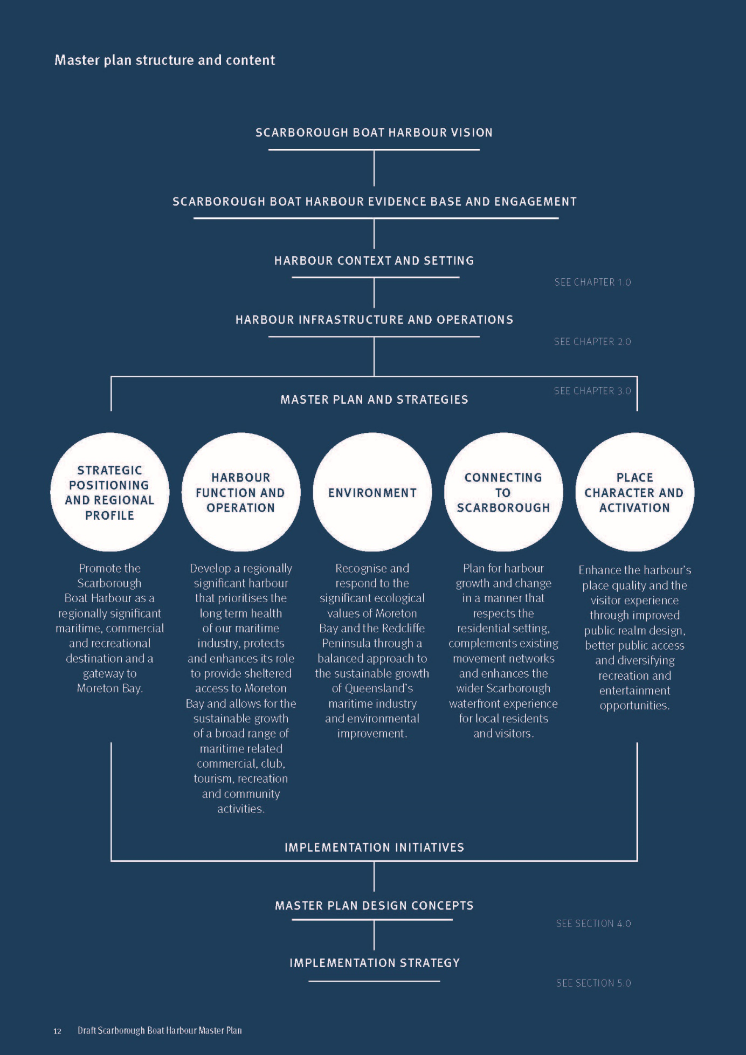

What we have heard
TMR undertook a program of community engagement in late 2021 to understand community and stakeholder values about the harbour, as well as ideas about current and future use.
An awareness and positioning campaign supported a variety of in-person and online activities during the engagement period. This engagement included briefings for a selection of key stakeholders to provide an overview of the project and to hear any preliminary ideas for the boat harbour.
The subsequent master planning process has drawn on the findings from this engagement activity, and expanded on the consultation with key stakeholders, local government representatives and Queensland Government agencies.
Key areas for consideration identified so far through community engagement:

Built form and function
- Improving marine facilities within the harbour to enhance user experience and support industry
- Improving hospitality, dining and retail options
- Creating more events, activities and activations
- Providing more parklands for people to enjoy
- Supporting water-based tourism attractions and opportunities.

Accessibility
- Increasing the capacity of boat ramps and improving direct water access
- Creating connections from the harbour out to Moreton Bay
- Addressing ‘missing links’ in pathways
- Improving access to parking within the harbour
- Investigating ways to improve safety.

Preservation
- Protecting what makes the harbour special
- Maintaining harbour views and sense of community
- Ensuring future enhancements are consistent with the primary purpose of a boat harbour.

Environment
- Protection of the natural environment, wildlife and habitats
- Enhancing green spaces and planting more trees
- Maintaining the harbour and its cleanliness.

Public infrastructure
- Creating more playgrounds and BBQ areas to enjoy
- Installing more park furniture, such as seating and picnic shelters
- Providing additional toilets in areas of high usage
- Improving signage and wayfinding
- Increasing lighting and visibility along pathways, in car parks and in the harbour.

Scarborough Boat Harbour engagement in numbers
- 6.5 week engagement period
- 30,000 fact sheets delivered to households and businesses in the Redcliffe Peninsula
- 3,002 visits to the project webpage
- 420 pieces of feedback received.

Harbour context and setting – Section 1

Harbour growth and change
Scarborough’s scenic bayside setting as well as its appeal for recreational boat owners and maritime industry activities have been synonymous with the suburb’s reputation and lifestyle as far back as the first housing estate sales in the late 1800s. Designated as a state boat harbour in 1960, the first stages of the Scarborough Boat Harbour were completed in 1968 and growth in both recreational and industry activities have seen the harbour change and expand. The harbour has evolved over many decades to its current form, with a significant acceleration in change over the past three decades.
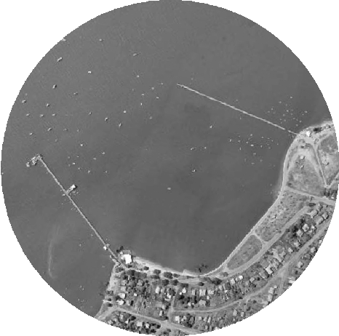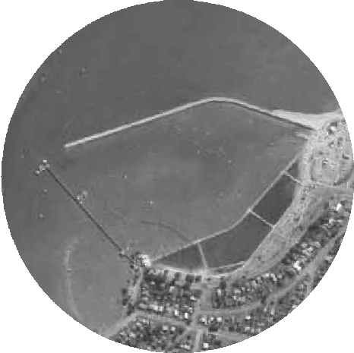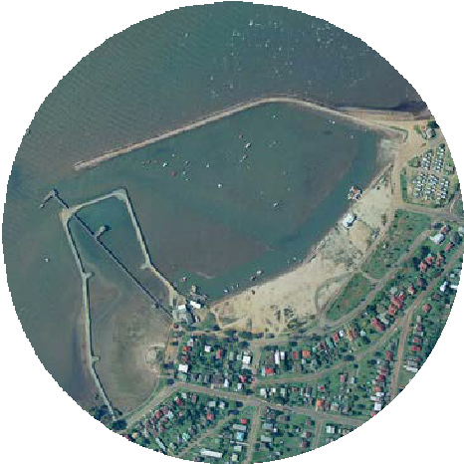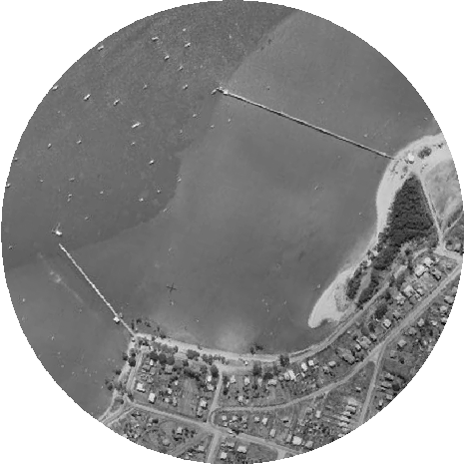
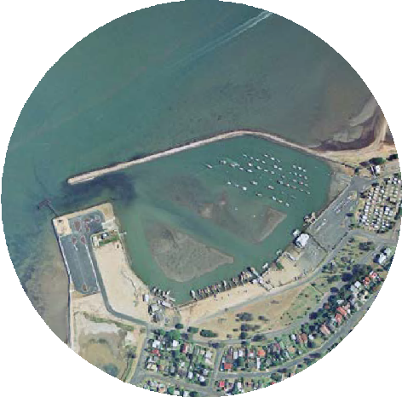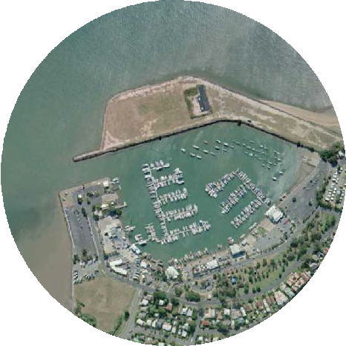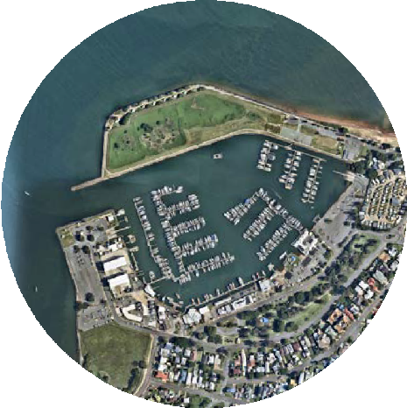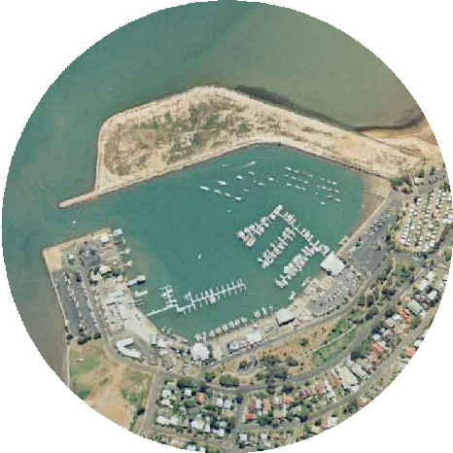

Context and place qualities
Boat harbours possess a distinctive sense of place. Their appeal as destinations for tourists and visitors is shaped by the coastal landscape, boating activity and the visual qualities of expansive marina infrastructure.
Scarborough Boat Harbour holds a prominent position on the northern tip of the Redcliffe peninsula and offers spectacular bay viewing experiences with both mountain and island backdrops. Its interface with the predominantly low density residential suburban area of Scarborough is buffered by open space. These connected parks and green spaces form part of a continuous parkland and active movement network that encompass the entire Redcliffe peninsula, including the popular Moreton Bay Cycleway and a seaside walking trail.
In addition to these outstanding locational attributes, the core driver of the harbour’s function and place character is the mix and interrelationship of traditional marine activity and infrastructure, recreation destinations and open spaces. The visual and experiential qualities of the working harbour and its boating activity are intrinsic to its authentic visitor experience and tourism appeal.
The intent of this master plan is to protect the core state harbour functions while increasing its role in the tourism economy and broadening benefits for the community. Future change and new development must integrate with, and draw value from, its regional location, coastal setting and the harbour’s inherent characteristics as a working harbour. This will be achieved through a master plan that is responsive to context and place and considers:
- Protecting and drawing value from the scenic coastal landscape and wider Moreton Bay environmental values
- Respecting the lifestyle amenity of the neighbouring residential environment of Scarborough
- Complementing Redcliffe peninsula’s regional open space and active movement networks
- Building upon existing businesses and recreation attractors to establish a greater critical mass of associated harbour commercial, tourism and leisure activity.
Figure 2: Context and place qualities

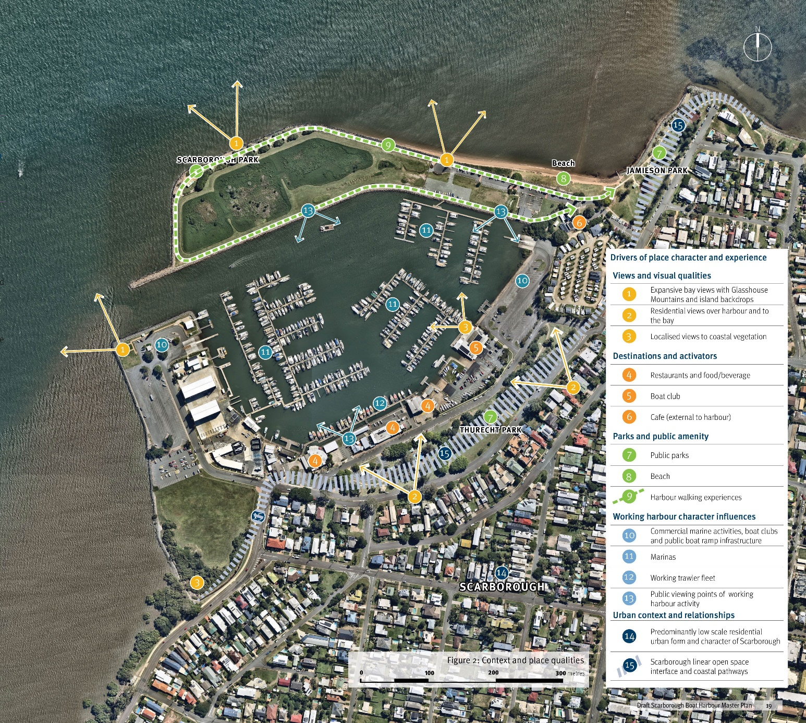

LEGEND

Drivers of place character and experience

Views and visual qualities
- Expansive bay views with Glasshouse Mountains and island backdrops
- Residential views over harbour and to the bay
- Localised views to coastal vegetation

Destinations and activators
- Restaurants and food/beverage
- Boat club
- Cafe (external to harbour)

Parks and public amenity
- Public parks
- Beach
- Harbour walking experiences

Working harbour character influences
- Commercial marine activities, boat clubs and public boat ramp infrastructure
- Marinas
- Working trawler fleet
- Public viewing points of working harbour activity

Urban context and relationships
- Predominantly low scale residential urban form and character of Scarborough
- Scarborough linear open space interface and coastal pathways

The harbour’s economic role
Scarborough Boat Harbour is capable of offering a broad range of tourism, recreation, community and marine functions that can positively contribute to our local and regional economies.

Economic exchange and growth
The boat harbour contributes to the wider Redcliffe and Moreton Bay regional economy through the direct and indirect expenditure of businesses and organisations that utilise the harbour wet and dry areas. There is significant opportunity to increase expenditure generated by the harbour through its future development.
The economic contribution of the boat harbour is underpinned by the diverse range of commercial businesses including maritime industry, trawling industry, boating and hospitality. Water and land- based recreation and tourism activities also support employment and economic exchange at the harbour. Protecting and enhancing these core harbour functions will be key to future success and economic performance.
There are a wide array of economic benefits are anticipated from continued investment in the Scarborough Boat Harbour. High quality public realm and infrastructure is needed to support increased visitation to existing businesses. Investment in transport, tourism and community infrastructure will provide strong foundations for economic growth. Future development should accommodate a diversity of tourism activities and experiences.
Indirect annual expenditure is likely to be more substantial for the harbour, with direct annual expenditure estimated to be less significant.
The harbour will be a key destination, unlocking opportunities for new businesses and operators to establish within the harbour will boost the industry and deliver additional skilled jobs and economic contributions to the local and regional economy.

Increasing demand for marina berths
The recreational boating industry has been growing worldwide over the long term. The boating industry’s economic contribution to the local economy and wider Greater Brisbane area supports the sustainability and prosperity of the harbour.
As marina berth demand grows, the opportunity to improve the economic sustainability of the harbour increases as do the economic benefits for the local economy. For the harbour to appropriately capitalise on the potential economic benefits associated with this strong and sustained growth in this industry, the provision of adequate marina berths to meet future demand should be a priority for future harbour planning.

Key drivers of demand for boat moorings:
- Growth in boat registrations, particularly large boats that are too large for a car and trailer
- Population growth, which is correlated to growth in boat registrations
- Proximity to the boat harbour, with owners most likely to moor their boat relatively close to home
- Access to popular boating destinations, with the islands of Moreton Bay being popular destinations for boating enthusiasts
- Affluence or disposable income. Boat ownership increases with affluence. A significant increase in the affluence of a region may increase the level of boat ownership. Growth in disposable income will drive boat sales
- Competition, or lack of new opportunities for competing harbours
- Price of moorings compared to competing harbours

- Amenity and the quality of facilities offered at the boat harbour.
- 1.22% growth per annum in boat registrations in Queensland from 2016
- Redcliffe produces $5 billion of Gross Regional Product for Queensland or 0.7% of total state Gross Regional Product
- 13.5% growth per annum in sailing club memberships in Australia from 2016 to 2021
- The harbour generates in the order of $20 milllion to $40 million in direct and indirect expenditure for the Scarborough local area
- 925,000 registered vessels within Australia
- 7% growth per annum in net personal water crafts in Queensland from 2016 to 2021
- Increasing demand for supporting marine infrastructure
- 1 in 10 Australians have a boat licence. Queensland has the highest number of perpetual licences in the country (July 2021)
- Development at the harbour could result in increased expenditure in the Scarborough local economy of $7.4 million to $8.9 million per annum
Sources: Economy.id, 2022, Maritime Safety Queensland Registered Vessel Census 2021, Australian Sailing Annual Reports, 2018 to 2021.

Enhancing tourism opportunity
Our climate, the spectacular bayside setting and access to internationally significant coastal environments provide the perfect ingredients to support the local tourism industry offering eco-tourism experiences, education and recreation. Scarborough’s boat harbour is not only a doorway to the bay but it holds broad potential as a destination its own right.

Growth in marine-related tourism
Marine tourism provides a substantial contribution to the economies of coastal communities. SEQ’s population lives in close proximity to the coast and accesses the local waterways for recreation purposes. Water based activities are also an important part of Moreton Bay’s tourism offer. As the region’s population and tourist numbers grow, it is anticipated there will be a continued increase in demand for these types of activities. This includes the demand for boat harbour facilities such as marina berths, boat ramps, tourist infrastructure, and food and beverage facilities.
The harbour is well placed to draw on its high scenic and natural amenity, providing a wide range of high- quality tourism opportunities that can contribute to the resilience of the local economy.
Any further development and expansion of tourism activities, to attract and grow visitor markets, will need to be supported by additional improved tourism infrastructure. High quality and well-designed public and private infrastructure should look to deliver tourism experiences that are compatible with the environmental values of Moreton Bay.

A conscious and balanced approach to tourism
Experiences in nature have always been a key driver for travel, and nature-based tourism is one of the fastest growing segments of the global tourism industry. Queensland provides a global destination for nature- based tourism, and directly responds to this growing international market. The Moreton Bay region has always been a well-known tourist destination, with waterfront locations like the boat harbour providing important gateways to experience the bay and access to islands.
Moreton Bay Marine Park offers a unique and precious environment and acts as a major draw card for visitors to the Moreton Bay region. Providing access to one of Queensland’s world class natural assets, the provision of activities such as fishing charters, wreck diving, whale watching, and sailing should be established in a sustainable way.

Connecting communities to the water and islands
Recent visitation numbers to Moreton Island have been at a record high. This increase in visitation and growth in nature-based tourism, provides a unique opportunity for Scarborough to leverage off and diversify its tourism offering.
It will be important that the harbour provides for a variety of attractions and inclusive access to the bay for local, regional, interstate and international tourists for day-trippers and overnight visitors. Private and public infrastructure and facilities should support a wide range of user groups, providing a diverse array of attractions and experiences. This may include self-drive tourism and Indigenous cultural heritage tourism opportunities.
The provision of dedicated deep-water marina berths for commercial vessels in conjunction with associated facilities such as booking offices and a dedicated tourism vessel jetty should be investigated. Expanding the wet lease area to cater for increased commercial operator berths has the potential to provide associated economic benefits to the local economy.
- Marine-based recreational fishing sub-sector was valued at $526 million, 2017 to 2018
- Natured based grown 14$ per annum from 2017 to 2019
- Tourism output of Redcliffe (inclusive of Moreton Island) is estimated at $161 million
- Adventure tourism to grown tenfold globally from 2020 to 2028
- Strong growth in visitation to Moreton Island
- Value added by tourism in Redcliffe (inclusive of Moreton Island) is estimated at $77.2 million
- Sources: Tourism and Events Queensland, 2021, Towards 2032: Reshaping Queensland’s visitor economy to welcome the world, 2022, Economy.id, 2022.

A vibrant dining precinct
Boat harbours also play an important role as local focal points for recreation and social gathering, including for the non-boating community. Scarborough has a strong legacy of providing fresh seafood and dining, with Morgan’s Seafood opening in 1985.
The entertainment and dining precinct along Bird O’Passage Parade connects the working harbour to the local community in a relationship that continues today. This combined offering of recreation and dining uses in conjunction with marine activities, where appropriately separated, is a successful formula for boat harbours around the world.
Scarborough Boat Harbour is an important node on the Redcliffe Peninsula, providing a boutique boating destination and recreational hub. Additional marine- related businesses and tourism opportunities including fishing and diving charters, restaurant cruises, yacht hire, and function facilities will provide new jobs and support economic growth at the harbour.
These attractions are important to provide a wide range of activities and experiences to diverse demographics, including visitors that don’t own a boat. Existing activities and dining experiences should be maintained and enhanced.

Environmental values
Scarborough Boat Harbour has a central role to play in the environmentally sustainable growth of the maritime industry and the management of coastal waterway access in a manner that positively contributes to the long-term health of the Moreton Bay Marine Park.

Moreton Bay
The Moreton Bay Marine Park extends from Caloundra south to Porpoise Point on South Stradbroke Island and possesses outstanding ecological values. A wide variety of habitats and species occur within the marine park, many of which are important at a state, national and international level including coral reef, mangroves, saltmarsh, dugongs, marine turtles, humpback and southern right whales, grey nurse sharks and migratory shorebirds.
The marine park provides valuable habitat for many recreationally and commercially important species of fish and for shorebirds to rest, refuel and, for thousands, a site to prepare for the annual flight to the Northern Hemisphere. The marine park’s zoning plan provides for the management and protection of shorebirds and their habitats.
Scarborough Boat Harbour provides an important launch point for people accessing the marine park and enjoying the natural amenity it provides.

A balanced approach to growth, with respect to the environment
The harbour provides an important link to natural areas for the growing local community. Boat harbour planning should exemplify a balanced approach to industry growth and increasing demand for public use with the preservation and enhancement of existing environmental values. There is an opportunity to maximise amenity whilst respecting the natural assets of the harbour, providing opportunities for education, awareness and active and passive recreation.
There are a number of important environmental areas within and surrounding the boat harbour. The harbour and surrounding marine environment area includes protected marine plants such as seagrasses and mangroves. Other areas of significance in the immediate surrounds include Jamieson Park to the north-east and The Blue Park to the south-west, which provide important interfaces to the harbour.
Future development activity within the harbour should look to integrate its natural assets to complement the coastal charm of the Redcliffe peninsula. Provision of required supporting infrastructure and facilities should be implemented in balance with retaining and enhancing the natural ecological values of Moreton Bay.
Scarborough Boat Harbour will be developed in line with Queensland legislative requirements for the environment, TMR’s Environmental Sustainability Policy as well as other TMR led aspects. The policy sets a clear vision for environmental sustainable management which includes reducing the environmental footprint, improving network resilience and adaptability, responding to climate change and contributing to sustainable practices and outcomes.

Education and awareness
Scarborough Boat Harbour has the opportunity to provide immersive experiences that enable visitors to enjoy the harbour, the bay and surrounding
waterfront. The harbour provides an important platform for education and awareness of cultural heritage, important ecological values, and marine habitat.
Educating visitors about appropriate behaviour and interaction with the landscape, environment and habitat and species should be explored. Knowledge, research and learning should be promoted through environmental and cultural heritage education and storytelling.

Harbour connectivity and access
The Scarborough Boat Harbour is well serviced and connected via the existing street network and surrounding major roads connecting to Redcliffe and beyond. Key active transport routes are already established and provide access to the harbour.

Vehicle access
Oyster Point Esplanade, Scarborough Road and Landsborough Avenue are just some of the key roads which provide vehicular access to the boat harbour for users coming from the Redcliffe Peninsula to the south, or coming from more inland suburbs to the west. These roads lead to Thurecht Parade, which provides direct access to the boat harbour. Users wishing to access the food and beverage area to the south of the harbour must then take Bird O’Passage Parade. The boat harbour generates traffic which can cause congestion and potential conflict along both Thurecht Parade and Bird O’Passage Parade, especially on weekends when the boat harbour, food and beverage venues and Thurecht Park attract a high volume of users. Road access improvements should prioritise safe pedestrian access, whilst facilitating good vehicular connectivity.

Active transport
Key active transport routes to the boat harbour are already established and provide access to the majority of the harbour area. The routes comprise off-road shared paths (e.g. through Thurecht Park, Jamieson Park and Scarborough Park), dedicated on road cycle lanes (although these are limited) and shared roads (typically local streets where cyclists share the road space with motor vehicles).
No active transport route exists on the final section of Thurecht Parade, north of the Oyster Point Esplanade intersection, that leads to the Thurecht Parade Boat Ramp.

Parking
The two public boat ramps each have their own car- trailer parking areas for boat ramp users. The Thurecht Parade Boat Ramp and trailer park in the northwest
of the boat harbour and the Bird O’Passage Parade Boat Ramp in the southeast of the boat harbour. The Moreton Bay Boat Club, food and beverage venues, marine activity businesses and other lessees supply an amount of car parking on site for use by members, workers and some visitors.
Car parking within the harbour is provided on a priority basis to the recreational boating community using the public marine facilities.
Single vehicle parking is provided in various locations throughout the harbour and surrounding areas. Due to increased demand at peak times on the weekend, it can be difficult for users to find a parking space close to the harbour.
Future development should review and consider the need for additional car parking, and ensure it can be reasonably accommodated to a level that services the generated additional demand.
Figure 3: Harbour connectivity and access
LEGEND
- Boat harbour boundary
- Primary active transport network
- Secondary active transport network
- Major road corridor
- Public transport - bus route
- Public boat ramp and car-trailer parking
- Public car parking
Figure 3 captions:
- On-street parking along esplanade
- Car park associated with café and park external to harbour
- On-street parking along Bird O’Passage Parade

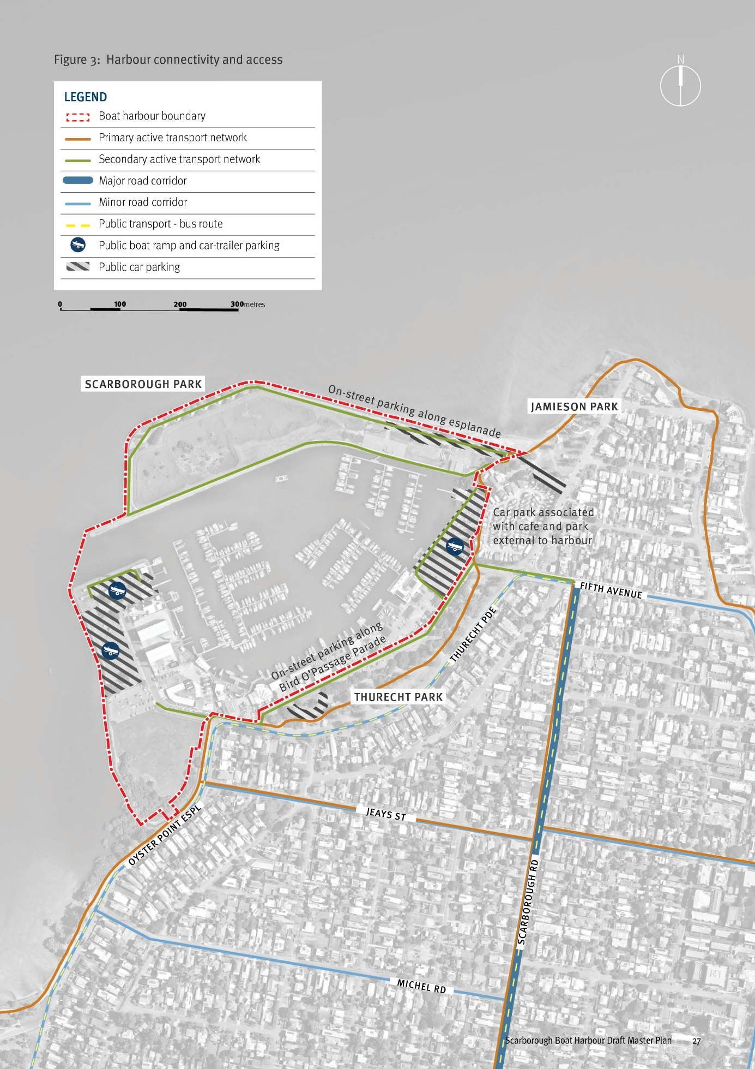

Harbour infrastructure and operations – Section 2

Industry trends to 2050
Local, national, and global trends that influence the development of the boat harbour addresses a wide range of factors including trends in recreational boating, vessel design, maritime industry activity and marine related tourism.

A growing maritime industry
The recreational maritime industry has been growing worldwide over the long term. It is influenced by a range of factors. These include increases in income, population growth, local and global effects such as the COVID-19 pandemic and economic cycles, supply of input materials and vessels, changing preferences for types of vessels, and innovations that lead to the introduction of new types of vessels.
Demand for recreational vessels continues to grow in Australia and Greater Brisbane specifically, with boating registrations experiencing sustained growth, even after a sharp increase during COVID-19. Combined with the increasing popularity of sailing as a sport and a recreational pastime, it is anticipated that demand for additional vessel berthing and associated facilities at Scarborough Boat Harbour will continue into the future.
Personal watercraft, such as jet skis, have been growing at almost 7% per annum (2016 – 2021). This substantial growth has been driving demand for additional boat ramp facilities, particularly at Scarborough. Paddle craft including Stand Up Paddle Boards (SUPs) or Kayaks (including canoes, and surf skis) have also been growing in popularity. Over the past five years the global market value of the SUP sector has been growing at 5.2% per annum and is expected to grow at around 9.7% over the next ten years to 2032.
This growth puts pressure on the boat harbour and surrounding marine infrastructure to provide adequate facilities and infrastructure to meet increasing demand while balancing functional and safety requirements.
Future investment at Scarborough Boat Harbour should focus on the provision of appropriate infrastructure and marine based facilities to meet this demand, including additional boat launching capacity or dedicated launching facilities for personal watercraft with reference to the latest Maritime Safety Queensland Recreational Boating Demand Forecast Study.

Sailing
Sailing has been a popular and successful sport for Australia over an extended period, facilitated by the high volume of population located in proximity to the coast and suitable waterways and our comparably high incomes.
In recent years sailing club memberships have grown strongly across Australia at 13.5% per annum. It is anticipated that this wider industry trend will see increased sailing activity at Scarborough Boat Harbour in the future, generating demand for supporting infrastructure and facilities.

Growth in large vessels
The largest growth in marina berths in Australia from 2013 to 2021 has been for berths greater than 24 metres at 3.8% per annum. This reflects the strong and growing demand for large vessels. In Australia, vessels over 24m in length are classified as superyachts.
The width and depth of the boat harbour’s entrance channel and its navigation channels accommodates access and berthing for vessels up to 25 metres. Larger vessels may frequent the harbour at higher tides. However, the boat harbour is unlikely to provide permanent berthing for larger vessels, unless the vessels were designed with a shallow draft. Alternatively, vessels with drafts exceeding the harbour depths may be operated by some marinas with the enforcement of certain sizes of vessels to employ retractable keels, or only transit the harbour at specific tidal ranges.

Maritime industry consolidation
There have been changes in the type and scale of maritime industry activity occurring in boat harbours and marinas across Australia. Of note is the decline in the proportion of marinas offering haul-out and lift-out services. The latest Health of the Australian Marina Industry Survey (2021) indicates that there has been a decrease of 22% (-3.1% per annum) in the number of marinas offering these services since 2012-13. This appears to be driven by the high cost of maintaining, insuring and staffing these facilities with these services being outsourced to nearby boat yards and other marinas.
Whilst haul-out and lift-out services have been declining and consolidating in marinas, fuelling and repair services have been increasing marginally. Over the period from 2013 to 2021 the proportion of marinas offering fuelling services increased by 0.6% per annum, and boat repair services increased by 0.3% per annum over this period. Whilst this represents growth, it has been at rates slower than the growth in vessels, marina berths, and population growth over the same period.

Electric and hydrogen vessels
The maritime industry is responsible for producing 2.5% of global greenhouse gas emissions. The use of electric and hydrogen vessels provides a sustainable alternative to reducing environmental impacts through smaller carbon footprints, powered by clean green energy, reduce impacts on wildlife and have emission free propulsion.
The increasing demand for electric and hydrogen powered boats has generated economic benefits through stimulating creativity and technological developments in the maritime industry. These vessels are in their early development and use; however, the future of the maritime industry will be impacted by electric and hydrogen boats becoming a more common choice in a response to environmental sustainability.

Harbour land uses, activities and operations
Scarborough Boat Harbour hosts dry and wet areas, plus two public boat ramps, one at each end of the harbour, and offers a scale of boating and cruising yacht facilities significant within the context of Australia’s eastern seaboard.

User groups of the harbour
There are a variety of user groups that may choose to operate within Scarborough Boat Harbour. Various user groups have a diverse range of land and water requirements, and number of vessels associated with the use. User groups include:
- Queensland Government agencies and emergency services
- Trailerable boats
- Paddle craft
- Off the beach sailing boats
- Recreational wet berth
- Commercial berth (fishing)
- Commercial berth (tourism i.e. fishing or charters etc.)
- Hardstand storage / dry stacker.

Harbour utilisation
The harbour’s average vessel size is approximately 14m, which has remained consistent since 2013, which is likely a reflection of the limits associated with channel and harbour depths.
The total number of vessels moored within boat harbour has increased by 10% over 10 years. These vessels can be broken down into three categories: Yacht, Power Boat, and Catamaran / Houseboat. Analysis indicated that the number of powerboats and multi hull vessels has increased, while the number of yachts has decreased over the period from 2013 to 2022.

Maritime infrastructure
Scarborough Boat Harbour accommodates three private marinas, two public boat ramps, Redcliffe Coast Guard and a commercial wharf for fishing trawlers. The marinas provide wet berths for vessel mooring, a drystack facility, hardstand areas for dry storage of vessels and boat maintenance facilities (slipways and travel lifts).
There are two existing public boat ramps located on the eastern (Bird O’Passage Parade facility) and western (Thurecht Parade facility) sides of the Harbour.

Maritime services
Core maritime services include dry stack storage for up to 123 boats and a small dry storage area within the Boat Club Marina. Refuelling facilities and boat maintenance services available include:
- Shipwright
- Marine trimming
- Boat detailing and upholstery
- Mechanics and marine engineering workshop
- Brokerage of vessels.

Queensland Government services
Department of Agriculture and Fisheries (DAF) and the Australian Volunteer Coast Guard each contain premises and operational vessels.
The DAF site is serviced by a pontoon located adjacent to the Harbour entrance channel and the facility is currently used as an operations base for the Queensland Boating and Fisheries Patrol.

Dredging
The harbour requires periodic maintenance dredging to maintain design depths. TMR is responsible for maintenance dredging of the entrance channel and internal channels leading to public infrastructure (e.g. boat ramps). Marina operators are responsible for the maintenance dredging within their respective lease areas.
Internally the harbour is surveyed annually with the last dredging campaign occurring in 2015. Maintenance dredging is required within the harbour every six to seven years based on historical dredging activities.
Establishing ongoing management of the dredge spoil will require collaboration with the tenants within the harbour. Investigations outline the dredge spoil facility is not required for TMR future dredging operations and temporary hardstand areas will be identified in the harbour to provide contingency for any contaminated dredge spoil material.
Figure 4: Harbour land use and activities
Figure 4 captions:
- Scarborough Park
- Dredge Spoil re-handling facility
- Department of Agriculture and Fisheries (DAF)
- Public marine facility
- Coast Guard
- Marina and maritime services
- Greenfield site for future harbour development/use
- Trawler berths, seafood processing, wholesale, retail and food and beverage
- Club and Marina
LEGEND
- Harbour boundary
- Maritime activity lease areas
- Dredge spoil re-handling facility
- Public marine facility
- Trawler berths, seafood processing, wholesale, retail, and food and beverage
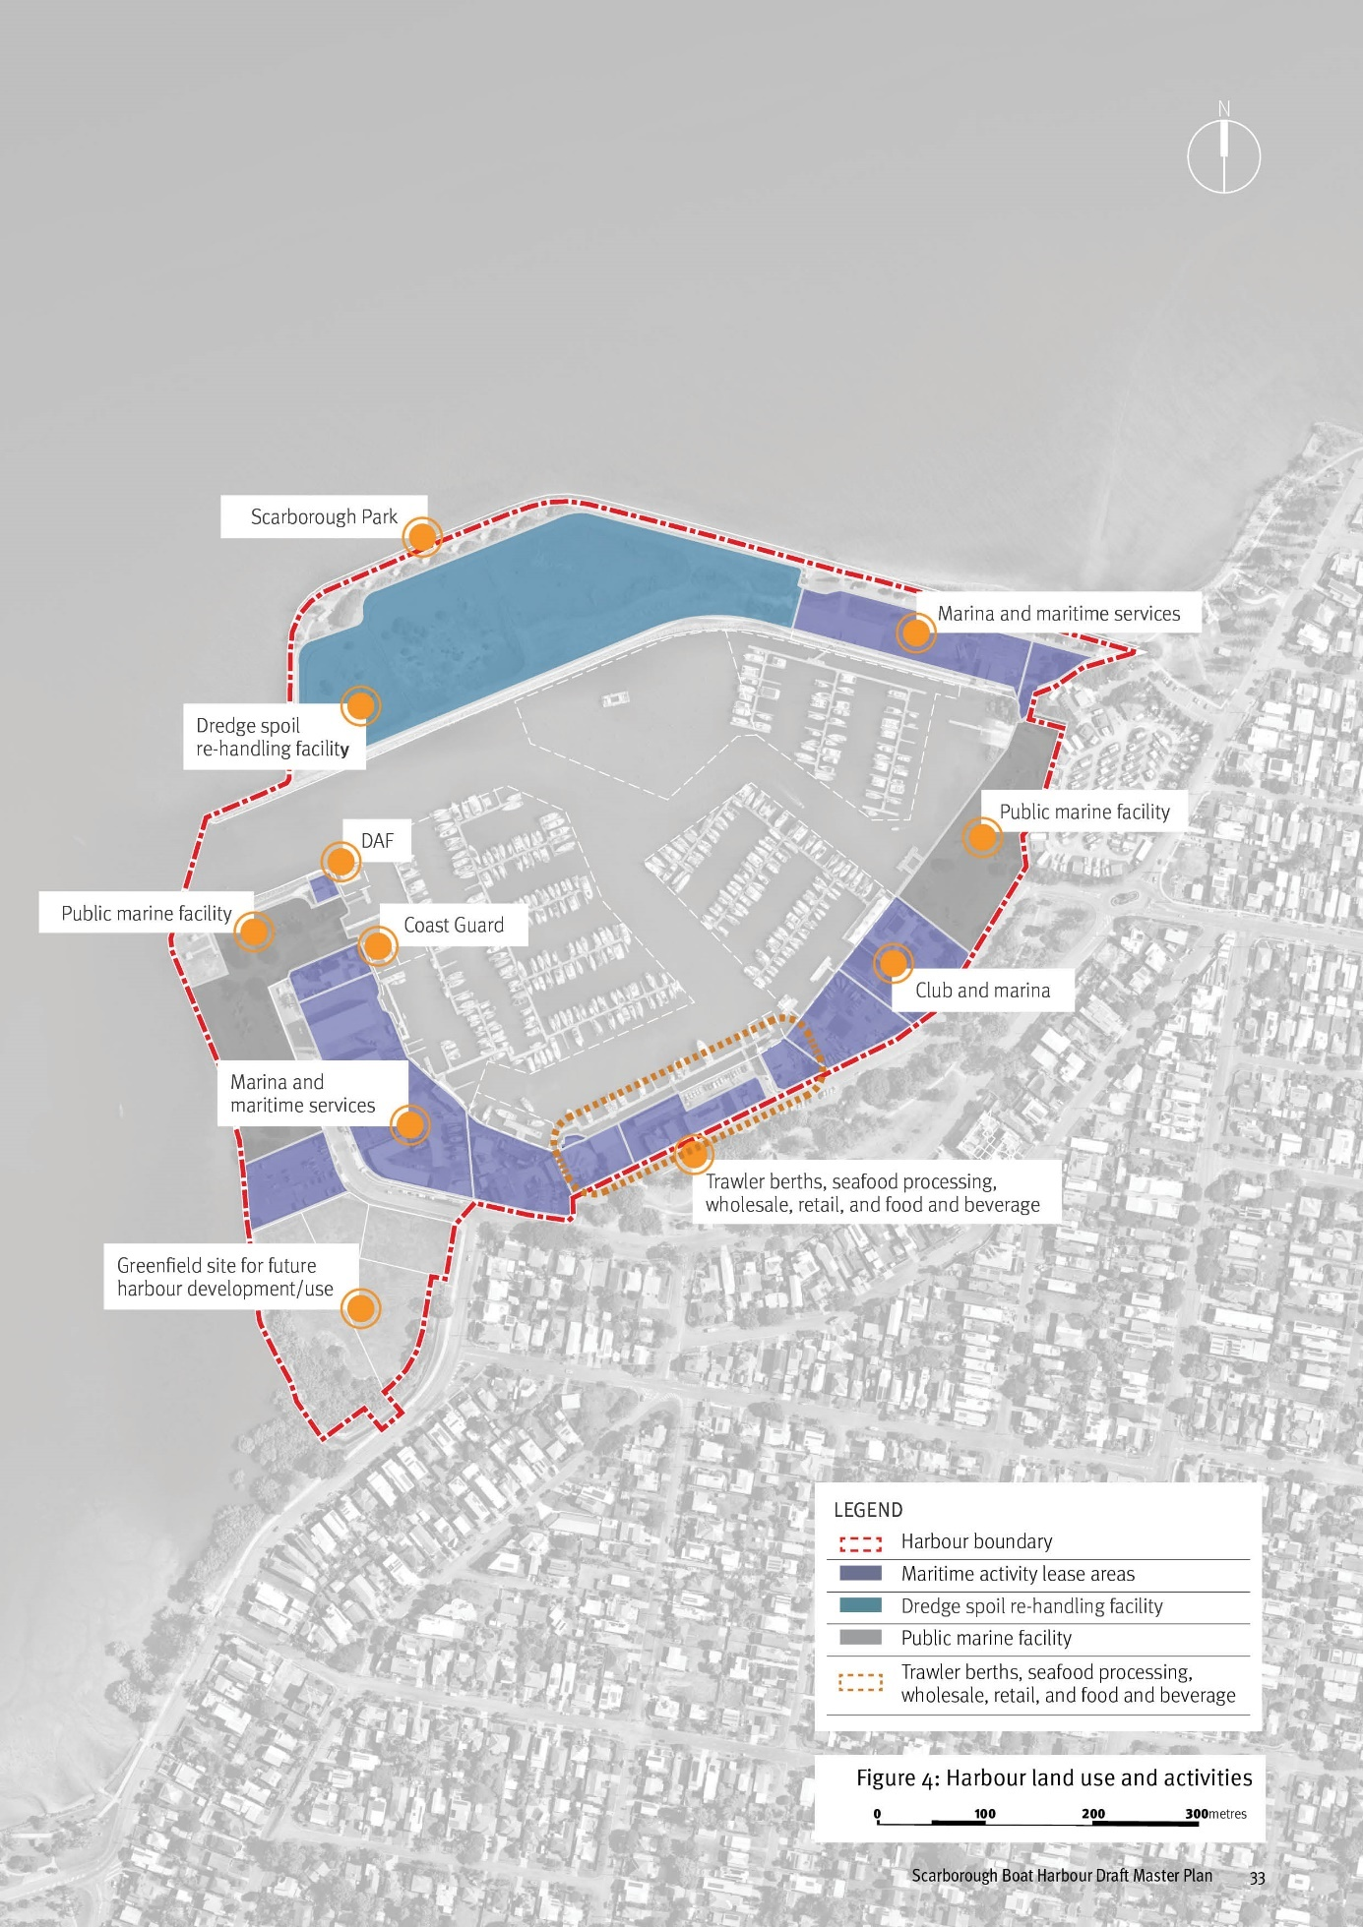

Master plan and strategies – Section 3

Scarborough Boat Harbour master plan and strategies
This master plan and its supporting strategies form a strategic decision-making tool offering greater certainty to government, investors, tenants and the community about the harbour’s future form and activity. They capture the broad opportunities presented by enhancing connection with Scarborough’s waterfront and harnessing the harbour’s potential as a key centre of boating and leisure activity within Moreton Bay’s wider network of maritime and tourism infrastructure. The goal is to sustainably address a growing maritime industry, engage the community, enhance the function and quality of the harbour, and elevate the harbour’s recreation and tourism role in a manner that protects the important ecological values and processes of the Moreton Bay Marine Park and surrounds.

Strategic positioning and regional profile
Promote the Scarborough Boat Harbour as a regionally significant maritime, commercial and recreational destination and a gateway to Moreton Bay.

Harbour function and operation
Develop a regionally significant harbour that prioritises the long term health of our maritime industry, protects and enhances its role to provide sheltered access to Moreton Bay and allows for the sustainable growth of a broad range of maritime related commercial, club, tourism, recreation and community activities.

Environment
Recognise and respond to the significant ecological values of Moreton Bay and the Redcliffe Peninsula through a balanced approach to the sustainable growth of Queensland’s maritime industry and environmental improvement.

Connecting to Scarborough
Plan for harbour growth and change in a manner that respects the residential setting, complements existing movement networks and enhances the wider Scarborough waterfront experience for local residents and visitors.

Place character and activation
Enhance the harbour’s place quality and the visitor experience through improved public realm design, better public accessa and diversifying recreation and entertainment opportunities.

Scarborough Boat Harbour

Master Plan
The master plan is a strategic decision-making and implementation tool offering greater certainty to government, investors, tenants and the community about the harbour’s future form and activity.
The plan spatially expresses the intent of the master plan strategies as a consolidated, flexible structure, identifying:
- The preferred arrangement of land use activities
- A structure of dry and wet lease areas building on current leases
- Recreation and community-accessible areas and facilities
- The walking and cycling network
- Access and road network connectivity.
Figure 5: Scarborough Boat Harbour Master Plan
Notes:
- Master plan responses and outcomes for areas under the jurisdiction of the Moreton Bay City Council are indicative only to help illustrate potential harbour opportunities, and are subject to the Moreton Bay City Council processes and decision making.
- Trawler facilities will be retained in their current location until alternative locations / facilities are available.
- Boat ramp capacity in the harbour will be retained.
LEGEND
- Harbour boundary
- Marine activities
- Marine activities - low impact
- Tourism, commercial and entertainment activities
- Mixed marine activities
- Marine activities - trawler facility and market
- Public boat ramp car-trailer parking
- Marine services
- Parkland and open space
- Open space - mangrove conservation
- Harbour (wet leases and navigation channels)
- Key road connections
- Existing active transport connections
- Proposed active transport connections
- Public car parking
- Bus stops
- Boat ramp
- Harbour wet lease expansion
- Paddle craft launch area
- Landscape buffer to residential (within Precinct 2)
- Harbour entry statement and wayfinding point

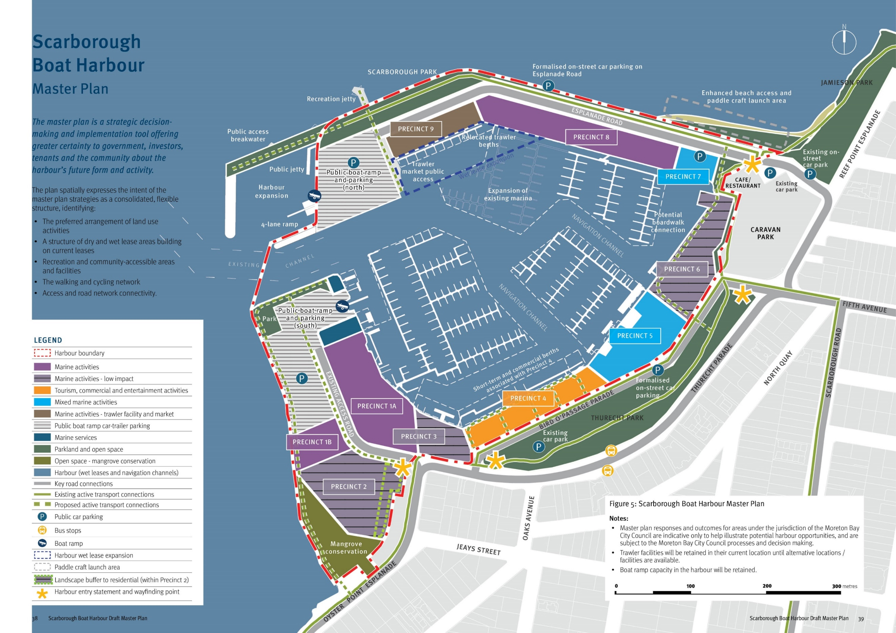

Strategy 1 - Strategic positioning and regional profile
Promote the Scarborough Boat Harbour as a regionally significant maritime, commercial and recreational destination and a gateway to Moreton Bay.
Scarborough Boat Harbour plays an important role in South East Queensland and the Moreton Bay City Council and positively contributes to our regional image, economy and lifestyles. The harbour also connects us to our premier natural asset Moreton Bay, offering tourism and recreation experiences as well as engaging us with nature and elevating our environmental awareness. Realising the full strategic potential of the harbour to our region will improve our local economy’s competitive advantage and secure broad benefits for the community.
STRATEGY OBJECTIVES

Profile and role
- Promote the regional profile and elevate community awareness of the harbour as a state and regionally significant centre of maritime, economic and recreation activity within Moreton Bay’s wider network of maritime and tourism infrastructure
- Promote the harbour’s strategic role in accommodating maritime industry growth and sustainably managing increasing public access to Moreton Bay’s waterways and tourism destinations
- Prioritise and protect the primary functions of the harbour as a location for maritime industry, home for a wide range of marine-based community organisations and the trawler industry, and a primary point of public access to Moreton Bay and its islands
- Support the growth of nature-based and marine tourism opportunities
- Utilise the harbour’s regional significance, history and identity as a working harbour to inform planning, public realm design and ongoing operations.

Regional and local economy
- Provide opportunities for job creation through the delivery of a balanced mix of maritime industry, commercial marina, commercial tourism, entertainment and recreation activities and infrastructure
- Attract a broad range of tourism, entertainment, recreation and commercial businesses and operators that elevate the harbour’s regional tourism function
- Coordinate with state and local tourism policy and strategy initiatives to maximise opportunities for commercial tourism functions that support the wider network of Moreton Bay tourism and recreation destinations and infrastructure
- Continue to support a sustainable trawler industry operating from the harbour, acknowledging the harbour’s proximity to the fishing grounds of ‘Moreton Bay Trawl Fishery’ and ‘East Coast Trawl Fishery’.

IMPLEMENTATION INITIATIVES
- Investigate branding and marketing options that position the harbour as a state-significant asset and raises business and community awareness of commercial and recreation opportunities
- Investigate and promote the expansion and development of a mixed-use harbour front area capable of accommodating a broad range of marine tourism, entertainment and recreation businesses that elevate the tourism profile and function of the harbour including:
  - engagement with Council, state agencies to identify initiatives and opportunities
  - investigate private sector investment opportunities in tourism products and event / experience infrastructure
- In recognition of the harbour’s strategic location and proximity to trawl fishery, engage with tenants, industry bodies and stakeholders to identify ways to promote the harbour, understand and meet infrastructure demand, and establish contemporary processes that address emerging trends in the maritime industry.
(Refer to Section 5.0 Implementation for timing and responsibility)
Figure 6: Moreton Bay tourism and maritime infrastructure

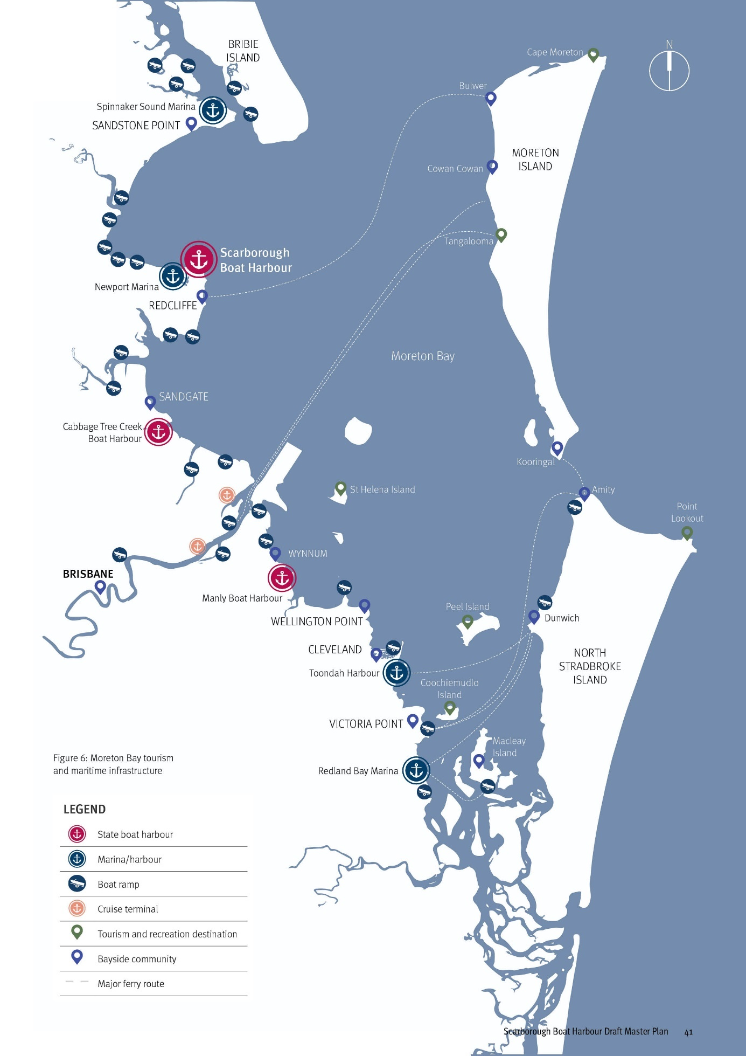

Strategy 2 - Harbour function and operation
Develop a regionally significant harbour that prioritises the long term health of our maritime industry, protects and enhances its role to provide sheltered access to Moreton Bay and allows for the sustainable growth of a broad range of maritime related commercial, club, tourism, recreation and community activities.
The commercial and recreational boating industry is forecast to experience continued growth. A comprehensive approach to managing this growth is essential to capture the economic and community benefits of Moreton Bay’s spectacular coastal landscape in a manner that protects its natural qualities and environmental health. Scarborough Boat Harbour has an important role to play in enabling industry growth and sustainably managing access to the Bay’s coastal islands and waters through the delivery of high quality marine infrastructure.
STRATEGY OBJECTIVES

Industry growth
- Maximise opportunities for the harbour to accommodate forecast increases in demand for:
- marine berths, boat storage and associated infrastructure and services
- recreational boating and public boat ramp infrastructure
- commercial marine tourism infrastructure
- commercial fishing and associated infrastructure
- short-term private boat mooring
- Enhance opportunities for the harbour to accommodate a broad range of community-based groups, volunteer organisations, boating clubs and state service providers

Harbour function and operations
- Establish a coordinated structure of harbour areas that deliver an optimal mix of maritime activities and commercial, service, recreational and community activities capable 0f attracting a range of tenants and commercial operators
- Ensure new marine infrastructure or improvements to existing marine infrastructure:
  - support safety and minimise conflicts and congestion between craft and different harbour users
  - maximise the efficient use of dry and wet lease harbour space
  - is of a high quality and designed to meet the requirements of the relevant Australian Standard
  - responds to changes and trends in vessel sizes and design and emerging technologies in the maritime industry
- Maximise self-containment of harbour activities by providing supporting maritime industry services and activities such as fuelling, vessel maintenance, sewerage pump out facilities, boat sales and retail services that are of an appropriate scale for the size and functions of the harbour
- Protect and enhance commercial fishing operations and infrastructure
- Provide highly accessible, dedicated space for water access of non-motorised craft for the public and recreational boating groups
- Sustainably manage dredge spoil storage, re- handling, treatment, and disposal and prioritise opportunities for beneficial reuse of dredged material

IMPLEMENTATION INITIATIVES
- Where required, undertake detailed technical investigations, and background monitoring consistent with Queensland legislative and regulatory requirements. Anticipated elements include:
- coastal processes and environmental values
- marine infrastructure and ground investigations
- cultural heritage and tenure and title
- Collaborate with harbour tenants to ensure a sustainable strategy is in place for the management of dredge spoil, consistent with relevant state policy and Queensland legislative requirements
- Investigate opportunities to consolidate government functions to maximise the efficient use of available land within the harbour
- Engagement with industry and relevant stakeholders to understand infrastructure demands and emerging trends in the maritime industry
- Retain trawler facilities at their current location and boat ramp capacity in the harbour until alternative locations / facilities are available
(Refer to Section 5.0 Implementation for timing and responsibility)
Figure 7: Strategy 2 - Master Plan Responses

Master plan responses
- Create a new protected harbour expansion area to enable the relocation of the existing eastern public boat ramp and car-trailer parking and create a new dry lease area on Bird O’Passage Parade
- Expand the harbour’s internal wet lease area to relocate trawler fleet operations and facilitate a potential market opportunity for direct to public seafood market
- Establish a coordinated structure of harbour leasehold areas that:
- delivers a range of lease opportunities that offer a variety of dry and wet lease options to suit a wide range of marine-based commercial operators, tourism and entertainment businesses
- establishes precincts within the harbour for appropriately grouped activities
- Provide a launch area for paddle craft to the external waters of the harbour including opportunities to establish an area for clubs and community groups (refer to Master Plan Precinct 7)
Note: Master plan responses and outcomes for areas under the jurisdiction of the Moreton Bay City Council are indicative only to help illustrate potential harbour opportunities, and are subject to the Moreton Bay City Council processes and decision making.

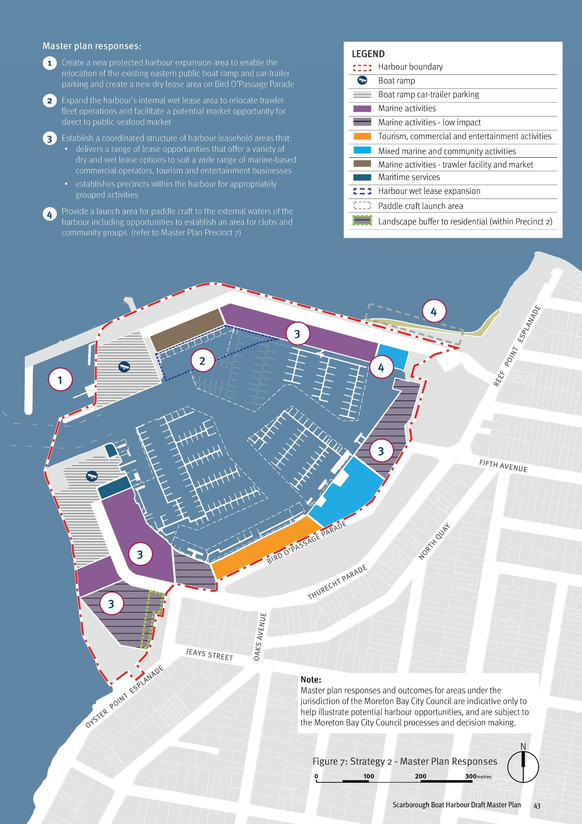

Strategy 3 - Environment
Recognise and respond to the significant ecological values of Moreton Bay and the Redcliffe Peninsula through a balanced approach to the sustainable growth of Queensland’s maritime industry and environmental improvement.
Moreton Bay is an internationally significant marine and coastal ecosystem. The planning, development and operation of the harbour is influenced by a complex and layered framework of local, state and federal environmental legislation that protects the ecological values and health of the Moreton Bay Marine Park. A comprehensive approach to the assessment pathways involving environmental assessments and master plan implementation and will be required to unlock the harbour’s potential and secure the long term sustainable growth of the maritime industry.
STRATEGY OBJECTIVES

Ecology and environment
- Maximise the harbour’s potential to accommodate growth of maritime industry activities and increasing demand for boat launching infrastructure to alleviate development pressures for new infrastructure within the Moreton Bay Marine Park
- Avoid, and where avoidance isn’t possible reduce and minimise, the potential impacts on terrestrial and marine habitats and coastal processes in future harbour improvements or changes, incorporating sustainable mitigation measures and suitable offsets where required
- Ensure future harbour interventions and development accounts for future coastal hazard and sea-level rise through its design and operation
- Avoid, and where avoidance isn’t possible reduce and minimise, ongoing impacts to water quality, coastal processes and ecological health through environmentally sustainable harbour operations and practices

Education and awareness
- Elevate awareness of the ecological values and sustainable use of the harbour and Moreton Bay waters through interpretive infrastructure and ‘smart’ or online platforms targeting community and tourist visitation
- Encourage nature-based tourism and eco-tourism businesses and operations to establish within the harbour that will contribute to the appreciation of, and coordinated management of Moreton Bay Marine Park

IMPLEMENTATION INITIATIVES
- Where required, undertake detailed technical investigations, and background monitoring consistent with Queensland legislative and regulatory requirements. Anticipated elements include:
- coastal processes and environmental values
- marine infrastructure and ground investigations
- cultural heritage and tenure and title
- Encourage private sector investment in new developments that seek to incorporate environmentally sustainable practices and align with current and emerging environmental and coastal development standards
- Collaborate with and encourage tenants to incorporate environmentally sustainable practices, consistent with environmental standards and legislation.
- Incorporate environmentally sustainable practices and innovative approaches in the delivery of state public marine infrastructure and encourage opportunities to support the transition to ‘net zero’.
- Identify opportunities to embed education on sustainable practices and awareness of ecological values in harbour planning and design and ongoing harbour operations that complements the harbour’s proximity to Moreton Bay Marine Park.
(Refer to Section 5.0 Implementation for timing and responsibility)

TMR environmental sustainability policy
TMR is a member of the Infrastructure Sustainability Council of Australia and aims to be an industry leader committed to:
- Managing our environmental interactions and incorporating sustainable and innovative solutions to minimise our environmental footprint as an integral part of our business activities
- Meeting the needs of the current generation while minimising environmental impacts on future generations
- Continuous improvement in environmentally sustainable practices, and partnering with our stakeholders to ensure a resilient and adaptable transport system
- Contributing to the sustainability of the natural environment, while delivering a single integrated transport network accessible to everyone.

Strategy 4 - Connecting to Scarborough
Plan for harbour growth and change in a manner that respects the residential setting, complements existing movement networks and enhances the wider Scarborough waterfront experience for local residents and visitors.
Scarborough is the northernmost suburb of the Redcliffe Peninsula and draws its character from the picturesque bayside setting and low density neighbourhoods. The boating, fishing and dining activities centered on the harbour,
as well as a broad choice of waterfront walking, cycling and picnicking experiences, contribute to its lifestyle-oriented reputation. As the harbour develops towards its full potential, there will
be opportunities to enhance relationships and connectivity with open spaces, active movement networks and the street network. This improved integration will secure the core role and activities of the harbour while elevating the recreation and leisure opportunities for local residents, visitors and tourists.
STRATEGY OBJECTIVES

Harbour integration
- Manage the place character and amenity of adjacent residential neighbourhoods through appropriate urban design responses addressing:
- land use transitions, buffers and landscape interface treatments between marine activities and residential areas
- scale and visual context of harbour buildings
- high quality public realm design of streets and open spaces
- Provide open spaces, active transport connections and recreation opportunities within the harbour that complement Scarborough’s broader waterfront recreation and movement experiences
- Ensure the harbour’s streetscapes and open spaces are designed to be highly integrated with Jamieson Park and Thurecht Park and the connecting streets

Access and connectivity
- Establish high levels of integration with existing access and movement networks and infrastructure including:
- road network and hierarchy
- public transport services and infrastructure
- active transport networks
- Require car parking to service harbour workers and visitors in a manner that minimises impacts on surrounding streets, including:
- on-street car parking dedicated for visitors
- private car parking within new development for workers and patrons
- Establish clear public access and wayfinding for the harbour that minimises conflicts between public visitation and commercial harbour operations and functions.

IMPLEMENTATION INITIATIVES
- Coordinate with state and local government stakeholders to develop a movement network and car parking strategy addressing:
- public transport
- active transport
- private vehicles and car parking (including public and private parking)
- recreation boat traffic and car-trailer parking
- service and commercial vehicles
- Northern Moreton Bay Tourist Drive
- Prepare a public access, signage and wayfinding strategy for the harbour that links to the surrounding area and other important local nodes, including creating a clear sense of arrival to the working harbour.
(Refer to Section 5.0 Implementation for timing and responsibility)
Figure 8: Strategy 4 - Master Plan Responses

Master plan responses
- Manage the character and amenity of adjacent neighbourhoods by locating low intensity and scale marine industry activities, buffers and appropriate development interfaces along Bird O’Passage Parade and Oyster Point Esplanade
- Complement and elevate Scarborough’s broader waterfront recreation and movement experiences with high quality open space, walking and cycling connections and new recreation opportunities within the harbour
- Integrate with, and enhance, existing public transport opportunities
- Integrate with the existing street network hierarchy and functions to minimise impacts of increased traffic and enhance the Northern Moreton Bay Tourist Drive experience
- Require appropriate levels of car parking to service publicly accessible destinations and minimise any impact on surrounding streets
- Express clear arrival points through streetscape design and wayfinding signage to welcome and guide visitors into the harbour
Note: Master plan responses and outcomes for areas under the jurisdiction of the Moreton Bay City Council are indicative only to help illustrate potential harbour opportunities, and are subject to the Moreton Bay City Council processes and decision making
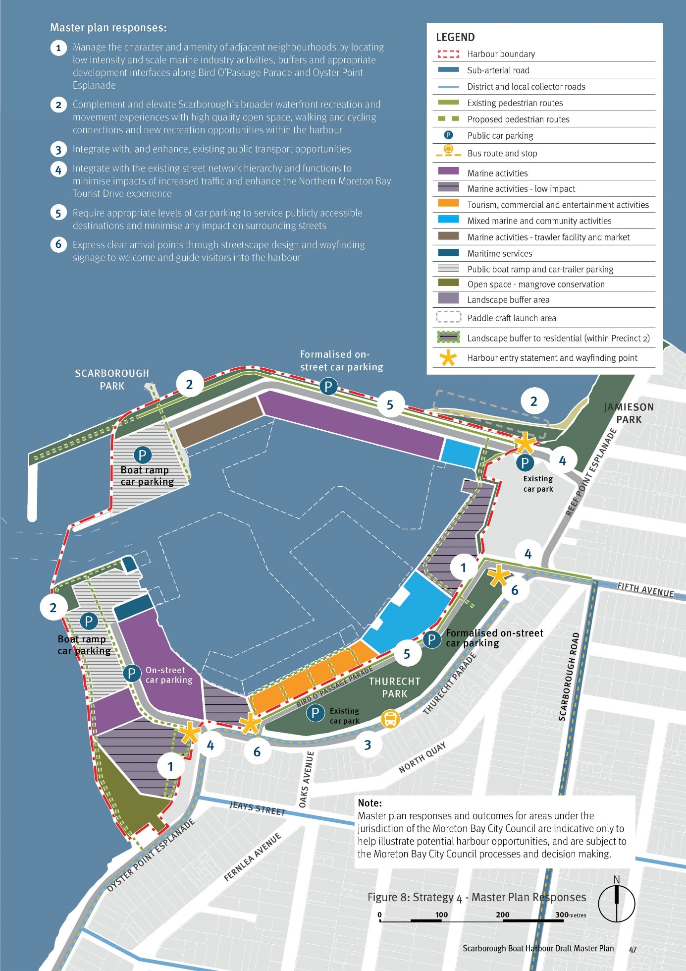

Strategy 5 - Place character and activation
Enhance the harbour’s place quality and the visitor experience through improved public realm design, better public access and diversifying recreation and entertainment opportunities.
Boat harbours possess a distinctive sense of place and offer a unique visitor experience. Scarborough’s harbour is a well-known destination on the Redcliffe peninsula, providing exceptional settings to engage the coastal landscape and experience a working harbour. A core goal of this master plan is to enhance public accessibility and the visitor experience to invite a broader range of people, families and tourists to enjoy the harbour and the bay. This will be achieved by strengthening access and connections to the harbour, improving the quality of the public realm and offering more diverse leisure and recreation activities that draw value from the harbour’s essential qualities and operations.
STRATEGY OBJECTIVES

Harbour activation
- Increase and diversify public activation of the harbour through the facilitation of a range of tourism, entertainment and recreation activities that complement the core role and maritime functions of the harbour
- Establish a consolidated harbourfront precinct that can deliver a critical mass of commercial tourism, leisure and recreation activities
- Engage with existing tourist and recreation experiences such as the Northern Moreton Bay Tourist Drive and coastal walking and cycling networks

Place character
- Protect and celebrate the intrinsic character and function of the harbour as a working waterfront that sustains commercial maritime activities
- Ensure new buildings or structures and public realm enhancements are of an appropriate scale, quality and character that respect the wider residential context and are capable of supporting a broad range of tourism, recreation and community activities

Public realm quality
- Deliver access and public realm enhancements capable of attracting a broad range of tourism and leisure businesses and service providers as well as community organisations
- Enhance the functional and visual quality of the public realm, addressing:
- active transport accessibility, safety and legibility
- open space function, character and quality
- streetscapes and car parks
- integration with Scarborough’s wider street and open space networks and infrastructure
- Reinforce a clear separation of public and maritime industry functions and access through public realm design and wayfinding signage
- Manage views and enhance visual relationships within and outside the harbour, including:
- buffering of marine activities
- minimising the visual impact of car parking or hard-stand areas

Cultural heritage
- In coordination with the Traditional Owners of the Scarborough area and Moreton Bay, seek opportunities to respect the area’s traditional cultural significance through the harbour planning process and future harbour operations.

IMPLEMENTATION INITIATIVES
- Engage with the Traditional Owners of Scarborough and Moreton Bay to identify opportunities to embed cultural history and meaning in harbour planning and design and ongoing harbour operations.
- Prepare a harbour public realm concept plan in consultation with the Moreton Bay City Council and leaseholders, that incorporates the movement network and car parking strategy, public access, signage and wayfinding strategy, and comprehensively addresses:
- public realm character and design quality
- accessibility, safety and wayfinding
- open space function and character
- streetscapes and car parking
- integration of adjacent parks, connecting streets and active travel networks
- public transport infrastructure
- Establish a program of works aligned to outcomes of the public realm concept plan and integrate within existing infrastructure planning, prioritisation and funding frameworks
(Refer to Section 5.0 Implementation for timing and responsibility)

Figure 9: Strategy 5 - Master Plan Responses

Master plan responses
- Create new open spaces and active movement experiences within that complement and connect to the network of coastal open spaces including:
- enhancement of Scarborough Park and the esplanade connection
- protection of mangroves and potential pathway connection to an enhanced park overlooking the harbour entry
- Enhance the beach access area formalising its use as a public launching location for paddle craft
- Expansion of waterfront tourism, entertainment and recreation activities including dedicated wet lease area for commercial tourism operators and short term visitor berthing
- Potential enhancement of Thurecht Park including integration with tourism, entertainment and recreation activities to provide a range of complementary event spaces, recreation settings and children’s play
- Potential redesign of Bird O’Passage Parade as a pedestrian prioritised shared streetscape adjacent tourism, commercial and entertainment activities
- Relocate trawler fleet to protect ongoing operations and potential opportunity for direct to public seafood market
- Provide high quality public boat ramp and jetty infrastructure.
Notes:
- Master plan responses and outcomes for areas under the jurisdiction of the Moreton Bay City Council are indicative only to help illustrate potential harbour opportunities, and are subject to the Moreton Bay City Council processes and decision making.
- Trawler facilities will be retained in their current location until alternative locations / facilities are available.
- Boat ramp capacity in the harbour will be retained.

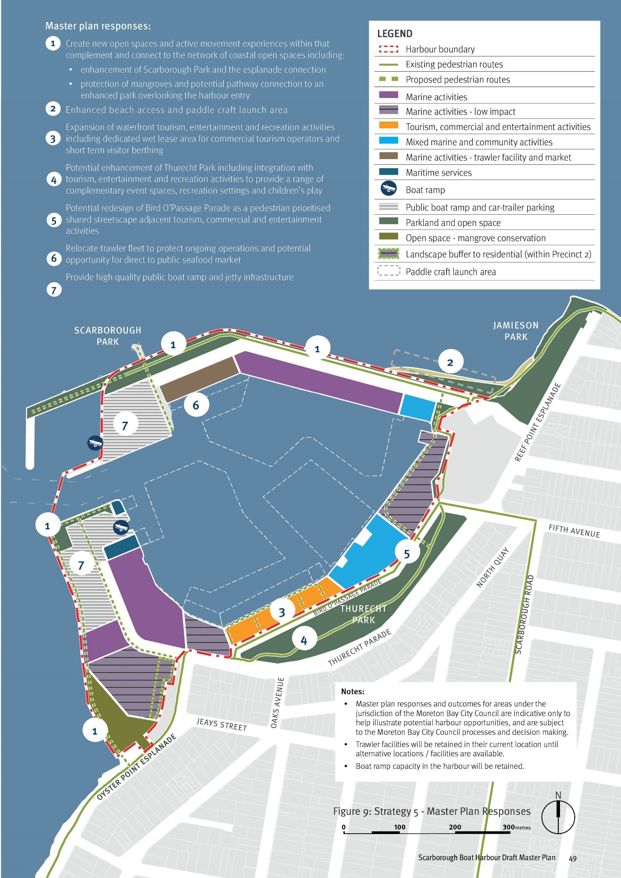

Scarborough Boat Harbour - Master Plan Areas
Figure 10: Master Plan Precincts

PRECINCT AND LAND USE ACTIVITY

Precinct reference | Precinct name | Area (Ha)
Precinct 1A | Marine activities | 1.63
Precinct 1B | Marine activities | 0.37
Precinct 2  (inclusive of buffer or transition area to residential) | Marine activities – low impact | 1.18
Precinct 3 | Marine activities – low impact | 0.40
Precinct 4 | Tourism, commercial and entertainment activities | 0.71
Precinct 5 | Mixed marine activities | 0.85
Precinct 6 | Marine activities – low impact | 0.94
Precinct 7 | Mixed marine activities | 0.17
Precinct 8 | Marine activities | 1.20
Precinct 9 | Marine activities – Trawler facility and market | 1.15
Public Boat Ramp and Parking | Boat Ramp North | 1.12
Public Boat Ramp and Parking | Boat Ramp South | 1.26
Marine services | Marine services | 0.20
Parkland and Open Space | Scarborough Park | 0.92
Parkland and Open Space | Open Space (Mangrove Conservation) | 0.73
Parkland and Open Space | Open Space (Boat Ramp South) | 0.24
Parkland and Open Space | Open Space (Holiday Village Buffer) | 0.18
Roads (and ancillary space) | Road 1 | 1.10
Roads (and ancillary space) | Road 2 | 0.50
Harbour | Wet Leases | 9.26
Harbour | Navigation Channels | 6.08
Total Area (TMR Property) |  | 29.04
New Boat Harbour (Public Boat Ramp) | Park (public accessible breakwater) | 0.30
New Boat Harbour (Public Boat Ramp) | Navigation harbour and breakwater | 1.42
Total Area (additional harbour area) |  | 1.72
Notes:
- Master plan responses and outcomes for areas under the jurisdiction of the Moreton Bay City Council are indicative only to help illustrate potential harbour opportunities, and are subject to the Moreton Bay City Council processes and decision making.
- Trawler facilities will be retained in their current location until alternative locations / facilities are available.
- Boat ramp capacity in the harbour will be retained.

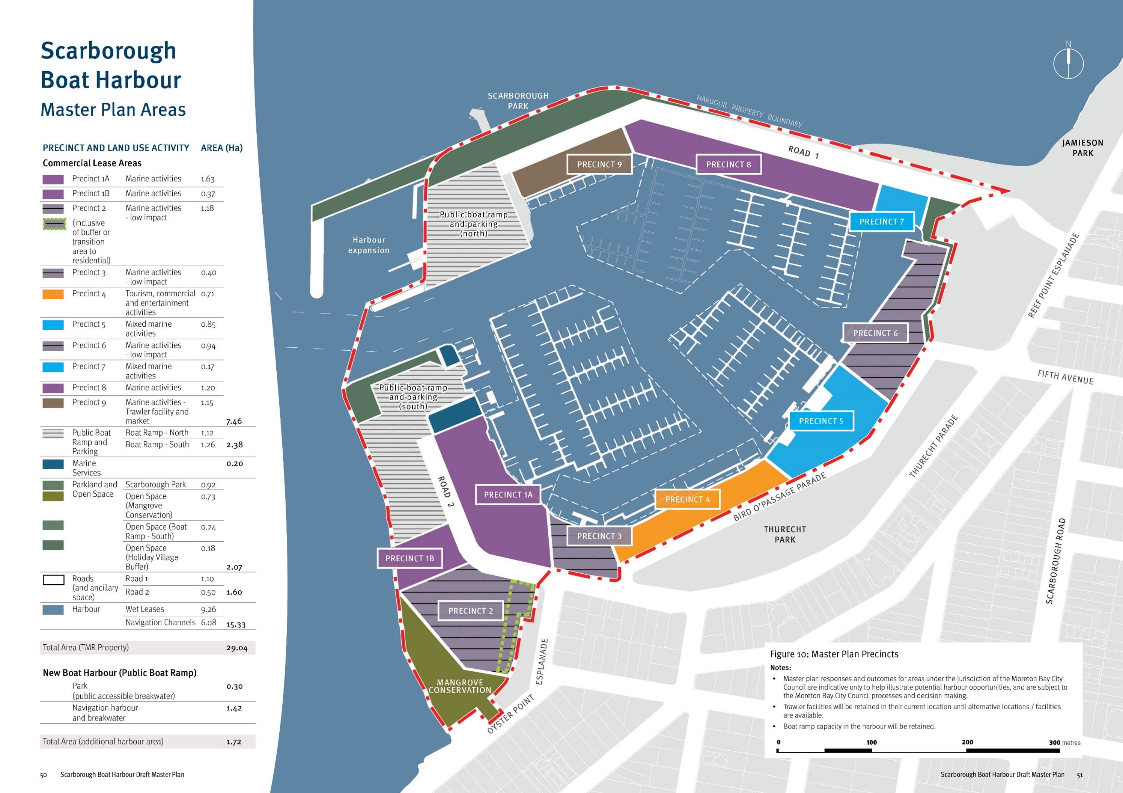

Harbour leases and activities
A key priority for the harbour is to diversify activity, attracting a mix of tenants that support the long term health of the maritime industry at Scarborough while strengthening the harbour’s profile and role as a tourism and recreation destination.

Diversifying harbour activity
In addition to their core maritime industry functions, a key factor in the success of comparable harbours across Australia is their activity mix. They offer a range of public attractors such as restaurants, bars and breweries as well as providing dedicated tourist infrastructure to support operations such as tour
services. These entertainment and recreation functions appeal to a wider range of people and leisure markets and strengthen harbours as destinations in their own right.
Dry and wet lease space is limited at Scarborough Boat Harbour, particularly looking out to a planning horizon of 2050. Space will become increasingly contested with the anticipated growth of commercial and recreational boating. This elevates the importance of planning for the appropriate balance of uses required to protect the primary maritime functions, allow for industry growth and diversify the activity mix
Building on the structure of existing leases and uses, it is proposed for the harbour to include:
- A wide variety of core commercial maritime industry functions and supporting services
- Supporting administrative and management uses
- Public boat ramps, jetties and associated car-trailer parking
- Commercial tourism operators
- Supporting retail and commercial services
- Community clubs and groups
- Volunteer organisations
- Queensland Government services
- Commercial entertainment and recreation
- Public open space and parkland

Land use structure and lease hold areas
The structure arrangement of land uses is also a critical success factor for harbours. Clear functional separation of maritime industry uses from publicly accessible destinations and spaces is required to avoid conflicts and minimise visual impact of industry on the public realm.
The master plan identifies nine leasehold areas which offer a range of dry and wet lease area opportunities that would appeal to a variety of potential investors or tenants (see plan opposite).
Figure 11: Harbour precincts and activities
LEGEND
Marine activities
Lease areas offering a broad range of maritime industry activity with associated wet leases. They consolidate and protect existing commercial marine industry activities and allow for expansion to meet industry demand in locations away from existing residential areas.
Marine activities - low impact
Lease areas that suit a range of low impact and scale marine or commercial uses requiring a public interface. They provide a logical land use intensity transition to public open spaces and residential areas. Low impact and scale uses will:
- not have significant noise or air emissions
- have hours of operation compatible with the surrounding context
- have articulated building forms and scale responsive to the surrounding context
Tourism, commercial and entertainment activities
A waterfront lease area that consolidates marine recreation and leisure activities such as food and beverage businesses and commercial marine tourism operators. A dedicated wet lease allows for commercial mooring and berthing for tourism vessels as well as recreational short term and day use berths.
Mixed marine activities
Lease areas that suit a range of low impact and scale marine industry and/or commercial uses requiring a public interface. They provide a logical land use intensity transition to public open spaces and residential areas.
Marine activities – trawler facility and market
A dedicated wet and dry lease area for trawler berthing and associated land uses is included as Precinct 9. This relocation may facilitate redevelopment of seafood processing and wholesale, and introduce a new public market and retail function associated with the trawlers. The relocation enables and enhances the commercial tourism and entertainment opportunities in Precinct 4.

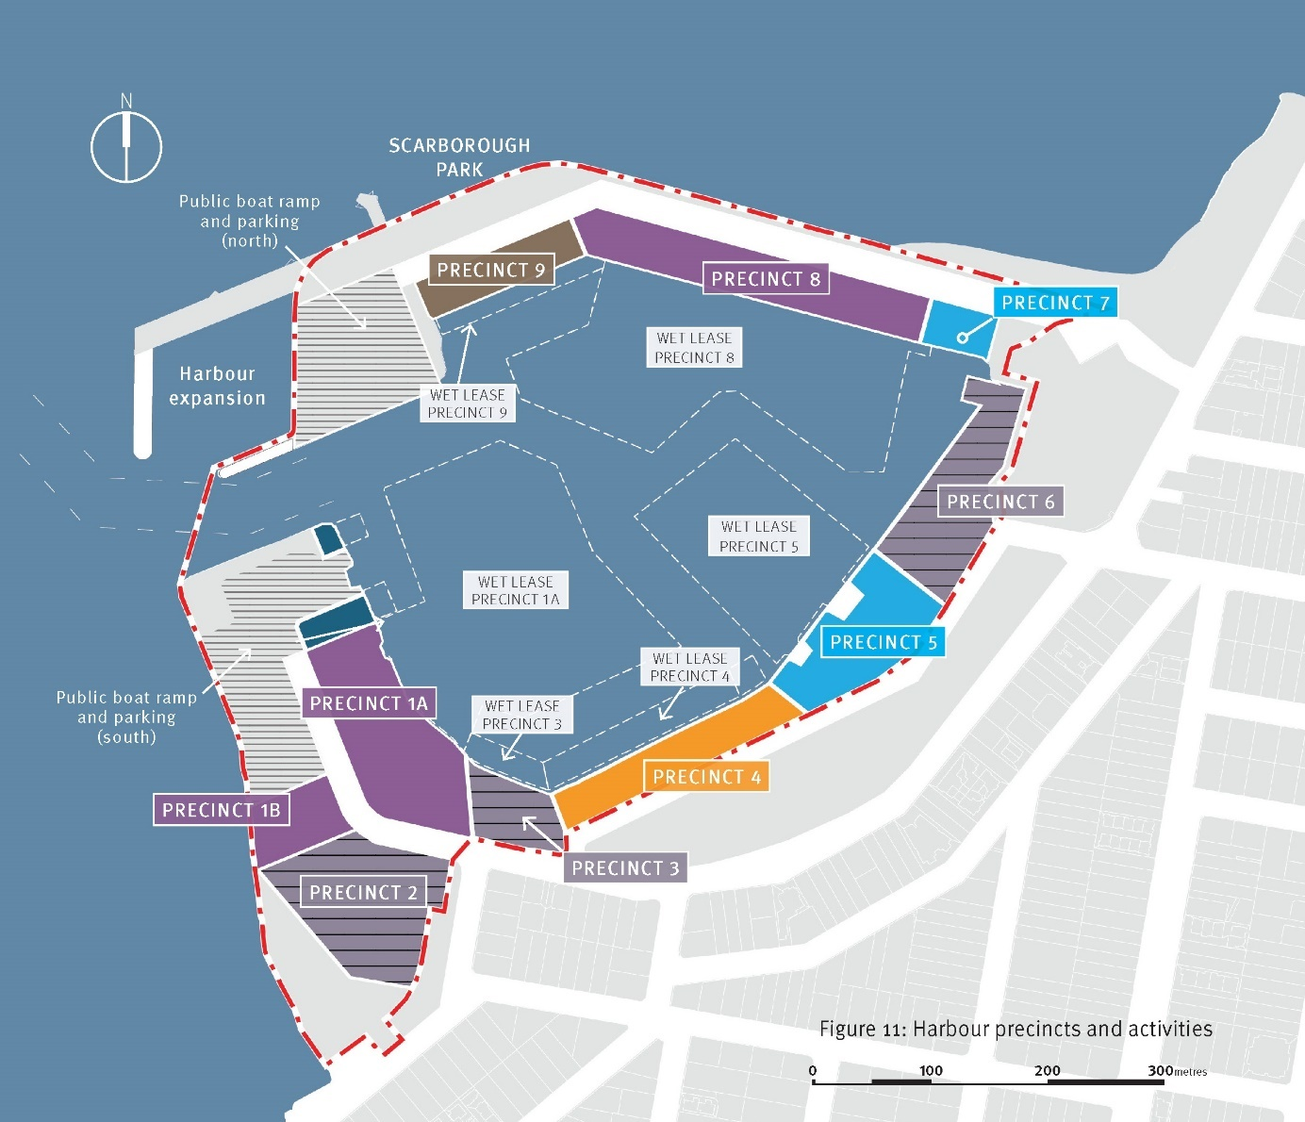
PRECINCT 1A, 1B and 8

Marine activities
Lease areas offering a broad range of traditional marine industry activity with associated wet leases.
Consolidates and protects existing commercial marine industry activities and allows for expansion to meet industry demand, in locations away from existing residential areas.
Changes in use remain subject to assessment processes and legislative requirements.

Indicative land use activity
- Recreational boat moorings and berths
- Mechanical, electrical services, marine engineering workshop
- Boat repair – sanding, painting, welding
- Boat maintenance
- Sail makers, marine trimmers, boat detailing, upholstery
- Travel lift
- Slip yard
- Fuelling facilities and fuel storage
- Dry storage:
  - Dock boatyards
  - Dry storage
  - General storage
- Chandlery
- Bait, tackle and ice supplies
- Convenience food and beverage
- Toilets, laundrette, showers
- Rubbish collection, sewage disposal, biosecurity facilities
- Administration office

PRECINCT 2

Marine activities - low impact
Lease areas that suit a range of low impact and scale marine or commercial uses requiring a public interface. They provide a logical land use intensity transition to public open spaces and residential areas.
Low impact and scale uses will:
not have significant noise or air emissions
have hours of operation compatible with the surrounding context
have articulated building forms and scale responsive to the surrounding context

Indicative land use activity
Mechanical, electrical services, marine engineering workshop
Boat maintenance
Sail makers, marine trimmers, boat detailing, upholstery
Fuelling facilities and fuel storage
Dry storage:
Dock boatyards
Dry storage
General storage
Chandlery
Bait, tackle and ice supplies
Convenience food and beverage
Administration office

PRECINCT 3 and 6

Marine activities - low impact
Lease areas that suit a range of low impact and scale marine or commercial uses requiring a public interface. They provide a logical land use intensity transition to public open spaces and residential areas.
Low impact and scale uses will:
- not have significant noise or air emissions
- have hours of operation compatible with the surrounding context
- have articulated building forms and scale responsive to the surrounding context

Indicative land use activity
- Recreational boat moorings and berths
- Mechanical, electrical services, marine engineering workshop
- Boat repair and maintenance
- Sail makers, marine trimmers, boat detailing, upholstery
- Travel lift
- Slip yard
- Fuelling facilities and fuel storage
- Dry storage:
- Dock boatyards
- Dry storage
- General storage
- Chandlery
- Bait, tackle and ice supplies
- Convenience food and beverage
- Toilets, laundrette, showers
- Rubbish collection, sewage disposal, biosecurity facilities
- Administration office

PRECINCT 4

Tourism, commercial and entertainment activities
A waterfront lease area that consolidates marine recreation and leisure activities such as food and beverage businesses and commercial maritime tourism operators. A dedicated wet lease allows for commercial mooring and berthing for tourism vessels as well as recreational short term and day use berths.

Indicative land use activity
- Commercial moorings and berths:
- Tourism
- Ferry services
- Fishing
- Charter services
- Boat hire
- Short term and day use berths
- Marine tourist attraction
- Booking offices:
- Information
- Event management
- Administration office
- Café’s / Coffee carts
- Restaurants / Bistro / Licensed premises
- Micro-brewery
- Fish monger
- Function facilities

PRECINCT 5 and 7

Mixed marine activities
Lease areas that suit a range of low impact and scale marine or commercial uses requiring a public interface or community focus.
Low impact and scale uses will:
- not have significant noise or air emissions
- have hours of operation compatible with the surrounding context
- have articulated building forms and scale responsive to the surrounding context

Indicative land use activity
- Recreational boat moorings and berths
- Harbour management offices
- Boat club
- Community-based groups
- Mechanical, electrical services, marine engineering workshop
- Boat repair and maintenance
- Sail makers, marine trimmers, boat detailing, upholstery
- Fuelling facilities and fuel storage
- Dry storage:
- Dock boatyards
- Dry storage
- General storage
- Chandlery
- Bait, tackle and ice supplies
- Convenience food and beverage
- Toilets, laundrette, showers
- Rubbish collection, sewage disposal, biosecurity facilities
- Administration office

PRECINCT 9

Marine activities – trawler facility and market
A dedicated wet and dry lease area for trawler berthing and associated land uses is included as Precinct 9.
This relocation may facilitate redevelopment of seafood processing and wholesale, and introduce a new public market and retail function associated with the trawlers. The relocation enables and enhances the commercial tourism and entertainment opportunities in Precinct 4.

Indicative land use activity
- Commercial fish receivals:
- Fish offloading facility
- Mooring of vessels (exclude live- aboards)
- Seafood processing
- Wholesale distribution
- Cold storage
- Associated market and retail front
- All uses identified in the Marine Activities precinct (where market activities are not feasible).

Master plan design concepts – Section 4

Master plan design concepts
REALISING THE HARBOUR’S POTENTIAL
Boat harbours possess a distinctive sense of place. Their appeal as
destinations for tourists and visitors is shaped by the coastal landscape,
boating activity and the visual qualities of expansive marina infrastructure.
Drawing on this character, the unique visitor experience they
possess can be enhanced through a comprehensive approach to
placemaking and public realm design.
Scarborough is the northernmost suburb of the Redcliffe Peninsula and draws its valued sense of place from the picturesque bayside setting and predominantly low density housing. The thriving seafood industry centered upon the Scarborough Boat Harbour has contributed to its regional reputation as a recreation destination.
As the harbour develops to its full potential, there will be opportunities to deliver broad community benefit for the local community and visitors while protecting the essential character of the area.
Figure 12: Scarborough Boat Harbour Concept Master Plan
Notes:
- Master plan responses and outcomes for areas under the jurisdiction of the Moreton Bay City Council are indicative only to help illustrate potential harbour opportunities, and are subject to the Moreton Bay City Council processes and decision making.
- Trawler facilities will be retained in their current location until alternative locations / facilities are available.
- Boat ramp capacity in the harbour will be retained.
Figure 12 captions:
- New breakwater offering viewing and fishing opportunities
- New public boat ramp facility and car-trailer parking
- Scarborough Park widening and enhancement
- Maintain government services
- Park enhancement and improved connection
- Maintain public boat ramp and car-trailer parking area
- Marine activities
- Marine activities – low impact
- Waterfront walking and cycling path
- Landscape buffer to residential interface
- Magrove conservation
- Waterfront walking and cycling path upgrades
- Expanded marine activities
- Trawler facility, seafood processing and potential wholesale direct to public market space
- Extended wet lease opportunity
- Maintain existing structure of wet leases
- Dedicated berths for tourism operators and short term public berths
- Tourism, commercial and entertainment activities
- Mixed marine activities
- Streetscape enhancement and additional car parking
- Dedicated club and community facility for paddle craft groups
- Potential Thurecht Park enhancement and integration with wharf
- Enhanced public transport opportunities
- Jamieson Park integration and coastal walk connections
- Enhanced beach access and launch area for paddle craft
- Improved harbour entries and wayfinding signage

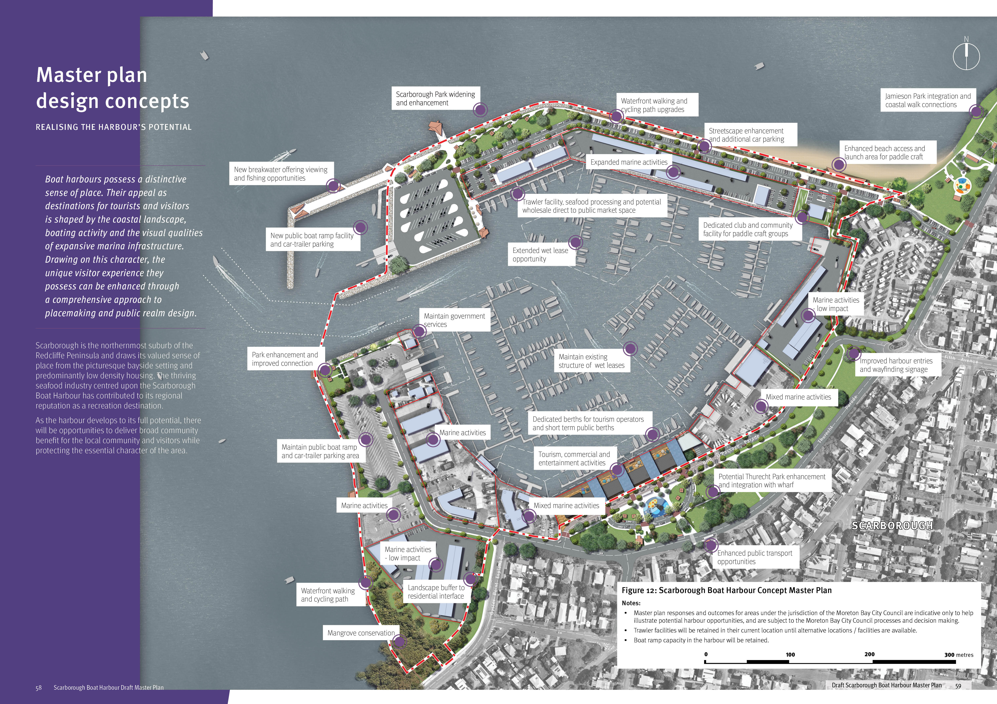

REALISING THE HARBOUR’S POTENTIAL

Design and placemaking
A comprehensive and coordinated approach to harbour planning, design and placemaking is required to fulfill the master plan vision for the Scarborough Boat Harbour.
Concept design and placemaking ideas are presented here that take the first bold steps in exploring and understanding the harbour’s potential. This commences an exciting process with the community, stakeholders and decision makers who have a vested interest in the harbour’s future and the sustainable growth of the maritime industry in our region.
The intent of these placemaking and design concepts is to inspire visionary, long-term thinking that aligns with the strategic timeframes required to achieve transformational change.
Partnerships with Moreton Bay City Council and state government agencies will be essential to coordinate development proposals with strategic and local planning frameworks and infrastructure network planning.
Master plan responses and outcomes for areas under the jurisdiction of the Moreton Bay City Council are indicative only to help illustrate potential harbour opportunities, and are subject to the Moreton Bay City Council processes and decision making.
The transition of the harbour towards the aspiration captured by the Scarborough Boat Harbour vision will ultimately be subject to comprehensive technical investigations, detailed precinct planning and design, stakeholder and community engagement, suitable development proposals, and government assessment processes (see Section 5.0 for further information).
Figure 13: Key Plan
Concept design and placemaking ideas are presented in detail on the following pages as a series of harbour areas defined by their role and activities.
- New public boat ramp facility
- Marine Activities – trawler facility and market
- Scarborough Boat Harbour recreation waterfront
- Mixed marine activities
- Tourism, commercial and entertainment activities
- Public boat ramp and marine activities

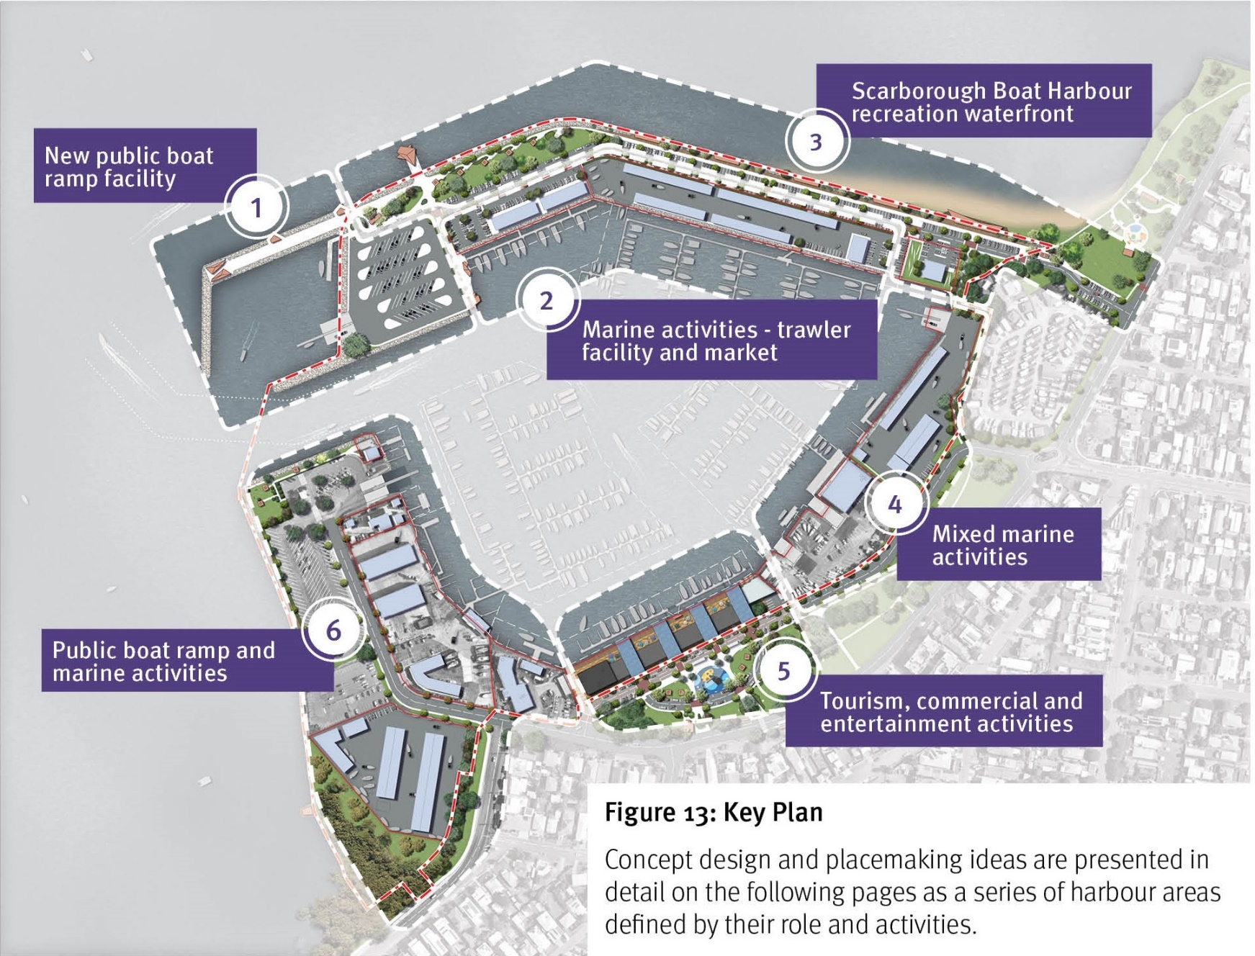

Alignment of design and placemaking concepts with master plan strategies
The concepts present high level harbour planning and design ideas for the harbour which respond to the many opportunities and challenges revealed through technical investigations, place assessments and stakeholder engagement. They are informed by the master plan strategies and explore strategic interventions and design concepts for key places that can positively contribute to the future of the harbour.
STRATEGIES AND CONCEPT DESIGN AND PLACEMAKING RESPONSES

STRATEGY 1 - Strategic Positioning and Regional Profile
- Prioritise and protect the primary functions of the harbour as a location for maritime industry, home for a wide range of marine-based community organisations and the trawler industry, and a primary point of public access to Moreton Bay and its islands
- Provide opportunities for job creation through the delivery of a balanced mix of maritime industry, commercial marina, commercial tourism, entertainment and recreation activities and infrastructure
- Support the growth of nature-based and marine tourism opportunities
- Utilise the harbour’s regional significance, history and identity as a working harbour to inform planning, public realm design and ongoing operations
- Engage with existing tourist and recreation experiences such as the Northern Moreton Bay Tourist Drive and coastal walking and cycling networks.

STRATEGY 2 - Harbour Function and Operations
- Maximise opportunities for the harbour to accommodate forecast increases in demand for:
- marine berths, boat storage and associated infrastructure and services
- recreational boating and public boat ramp infrastructure
- commercial marine tourism infrastructure
- commercial fishing and associated infrastructure
- short-term private boat mooring
- Enhance opportunities for the harbour to accommodate a broad range of community-based groups, volunteer organisations, boating clubs and state service providers
- Establish a coordinated structure of harbour areas that deliver an optimal mix of maritime activities and commercial, service, recreational and community activities capable 0f attracting a range of tenants and commercial operators
- Protect and enhance commercial fishing operations and infrastructure
- Provide highly accessible, dedicated space for water access of paddle craft for the public and recreational boating groups

STRATEGY 3 – Environment
- Maximise the harbour’s potential to accommodate growth of maritime industry activities and increasing demand for boat launching infrastructure to alleviate development pressures for new infrastructure within the Moreton Bay Marine Park
- Ensure future harbour interventions and development accounts for future coastal hazard and sea-level rise through its design and operation
- Elevate awareness of the ecological values and sustainable use of the harbour and Moreton Bay waters through interpretive infrastructure and ‘smart’ or online platforms targeting community and tourist visitation
- Encourage nature-based tourism and eco-tourism businesses and operations to establish within the harbour that will contribute to the appreciation of, and coordinated management of Moreton Bay Marine Park.

STRATEGY 4 – Connecting to Scarborough
- Manage the place character and amenity of adjacent residential neighbourhoods through appropriate urban design responses addressing:
- land use transitions, buffers and landscape interface treatments between marine activities and residential areas
- scale and visual context of harbour buildings
- high quality public realm design of streets and open spaces
- Provide open spaces, active transport connections and recreation opportunities within the harbour that complement Scarborough’s broader waterfront recreation and movement experiences
- Ensure the harbour’s streetscapes and open spaces are designed to be highly integrated with Jamieson Park and Thurecht Park and the connecting streets
- Establish high levels of integration with existing access and movement networks and infrastructure including:
- road network and hierarchy
- public transport services and infrastructure
- active transport networks
- Require car parking to service harbour workers and visitors in a manner that minimises impacts on surrounding streets, including:
- on-street car parking dedicated for visitors
- private car parking within new development for workers and patrons
- Establish clear public access and wayfinding for the harbour that minimises conflicts between public visitation and commercial harbour operations and functions.

STRATEGY 5 – Place Character and Activation
- Increase and diversify public activation of the harbour through the facilitation of a range of tourism, entertainment and recreation activities that complement the core role and maritime functions of the harbour
- Establish a consolidated harbourfront precinct that can deliver a critical mass of commercial tourism, leisure and recreation activities
- Engage with existing tourist and recreation experiences such as the Northern Moreton Bay Tourist Drive and coastal walking and cycling networks
- Protect and celebrate the intrinsic character and function of the harbour as a working waterfront that sustains commercial maritime activities
- Ensure new buildings or structures and public realm enhancements are of an appropriate scale, quality and character that respect the wider residential context and are capable of supporting a broad range of tourism, recreation and community activities
- Deliver access and public realm enhancements capable of attracting a broad range of tourism and leisure businesses and service providers as well as community organisations
- Enhance the functional and visual quality of the public realm, addressing:
- active transport accessibility, safety and legibility
- open space function, character and quality
- streetscapes and car parks
- integration with Scarborough’s wider street and open space networks and infrastructure
- Reinforce a clear separation of public and maritime industry functions and access through public realm design and wayfinding signage
- Manage views and enhance visual relationships within and outside the harbour, including:
- buffering of marine activities
- minimising the visual impact of car parking or hard-stand areas
- In coordination with the Traditional Owners of the Scarborough area and Moreton Bay, seek opportunities to respect the area’s traditional cultural significance through the harbour planning process and future harbour operations

1 – New public boat ramp facility
Providing accessible public boating infrastructure is a core objective of state boat harbours. Re-locating the existing boat ramp to the harbour’s entry enables additional marine activities within the harbour while catering for the growing demand for accessible, high quality public boat launch facilities.

Key design and placemaking concepts
- Creation of a purpose-built protected harbour as an extension of the harbour’s main arm can enable the relocation of the existing public boat ramp adjacent Bird O’Passage Parade. This allows that valuable area to be developed for other marine activities (see Master Plan Precinct 6) and a new high quality public boat launch facility. The new public marine facility will reduce vessel traffic within the harbour, improving the safety and efficiency of the harbour.
- The new facility will include a four-lane boat ramp, jetty and ample car-trailer parking
- The new breakwater can be designed as an extension of Scarborough Park and provide enjoyable walking and recreational fishing opportunities that elevate the visitor experience.
Image captions:
- Extended breakwater promenade
- Scarborough park foreshore park enhancements
- New boat ramp facilities
- New breakwater extending Scarborough Park walking and bay viewing
- Harbour expansion
Figure 14: Concept Plan - New public boat ramp
LEGEND
- Car-trailer parking
- Four-land boat ramp
- Public jetty
- New breakwater with public walkway
- Scarborough Park integration
- Public promenade edges to trawler facility

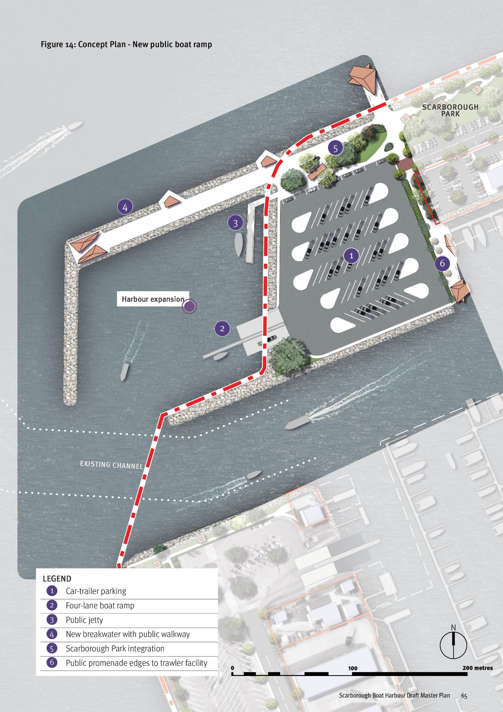

2 – Marine activities – trawler facility and market
Protecting maritime industry functions is a key objective of the master plan. By utilising the former dredge spoil re-handling area there are opportunities to provide additional high quality harbour front leases that expand and secure the core maritime activities of a working harbour.

Key design and placemaking concepts
- Expansion of the internal harbour (wet lease area) utilising the dredge spoil handling areas to create additional dry lease area that suits a range of marine activities (see 1)
- Re-location of the current trawler activities to a new lease area that offers room for associated land based activities such as administration, maintenance and storage facilities as well as dedicated car parking and service access (see 2).
- Opportunities for direct sales to public via a land based retail outlet or direct ‘off the boat’ sales through a purpose-built jetty arrangement that appropriately manages public access and safety (see 2 and 3)
- New marine activity wet and dry lease areas suitable for a commercial marina operator (see 5 and 6)
Image captions:
- New boat ramp and car-trailer parking
- New fishing trawler location
- Additional maritime industry areas
- Enhanced public waterfront and esplanade road
Figure 15: Concept Plan - Dedicated trawler facility and new marine activities precinct
LEGEND
- Trawler berths
- Dry lease area for trawler related land-based uses
- Public promenade edges to trawler facility
- Additional public car and trailer parking
- Dry lease area for commercial marina operator
- Wet lease area associated with commercial marina

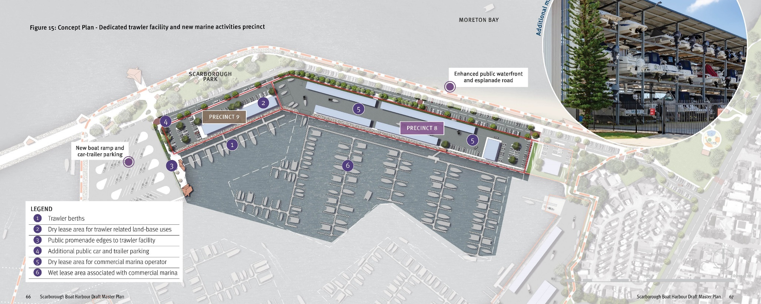

3 – Scarborough Boat Harbour recreation waterfront
Scarborough Boat Harbour boasts over 700m of north-facing frontage to Moreton Bay. This waterfront offers enormous recreation and tourism potential with opportunities to provide parkland and picnic facilities, walking and cycling paths, fishing spots and recreation paddle craft facilities. Designed as a high quality public realm characterised by the coastal landscape, this connected network of open spaces and destinations will establish a regionally significant recreation destination.
Figure 16: Concept Plan - Scarborough Boat Harbour recreation waterfront
LEGEND
- Enhanced entry and wayfinding from Reef Point Esplanade
- Connections to existing pathways
- Integration with Jamieson Park
- Paddle craft launch facility and enhanced beach access points
- Enhanced waterfront shared pathway with shelters
- Improved esplanade streetscape
- Expansion of Scarborough Park
- New bay viewing and fishing jetty
Note: Master plan responses and outcomes for areas under the jurisdiction of the Moreton Bay City Council are indicative only to help illustrate potential harbour opportunities, and are subject to the Moreton Bay City Council processes and decision making.
Image captions:
- Dedicated Trawler Facility
- Enhanced water edge with seating and shelters
- Walking and cycling paths
- Paddle craft launch facilities
- New marine activity precinct
- Enhanced access to beach

Key design and placemaking concepts
- Enhanced entry from Reef Point Esplanade including retention of car parking and clear wayfinding signage for visitors to the harbour (see 1)
- Connections to existing walking and cycling paths and integration with Jamieson Park and existing restaurant (see 2 and 3)
- Potential for existing car park and marina administration building to be utilised for a range of community groups associated with paddle crafts. This could include car-trailer parking dedicated for paddle craft users (see 4)
- Enhanced access to paddle craft public beach launch area (see 4)
- Enhanced walking and cycling pathway along the water’s edge including signage, shelters, shade planting and surface treatments that elevate the visitor experience (see 5)
- Improved esplanade streetscape including formalised public on-street car parking, street trees and landscaping (see 6)
- Expansion and enhancement of Scarborough Park building on existing elements and introducing new shelters, barbeques, amenities, lighting and shaded picnic spaces (see 7)
- A new viewing and fishing jetty as an extension to the park and walking/cycling opportunities (see 8).

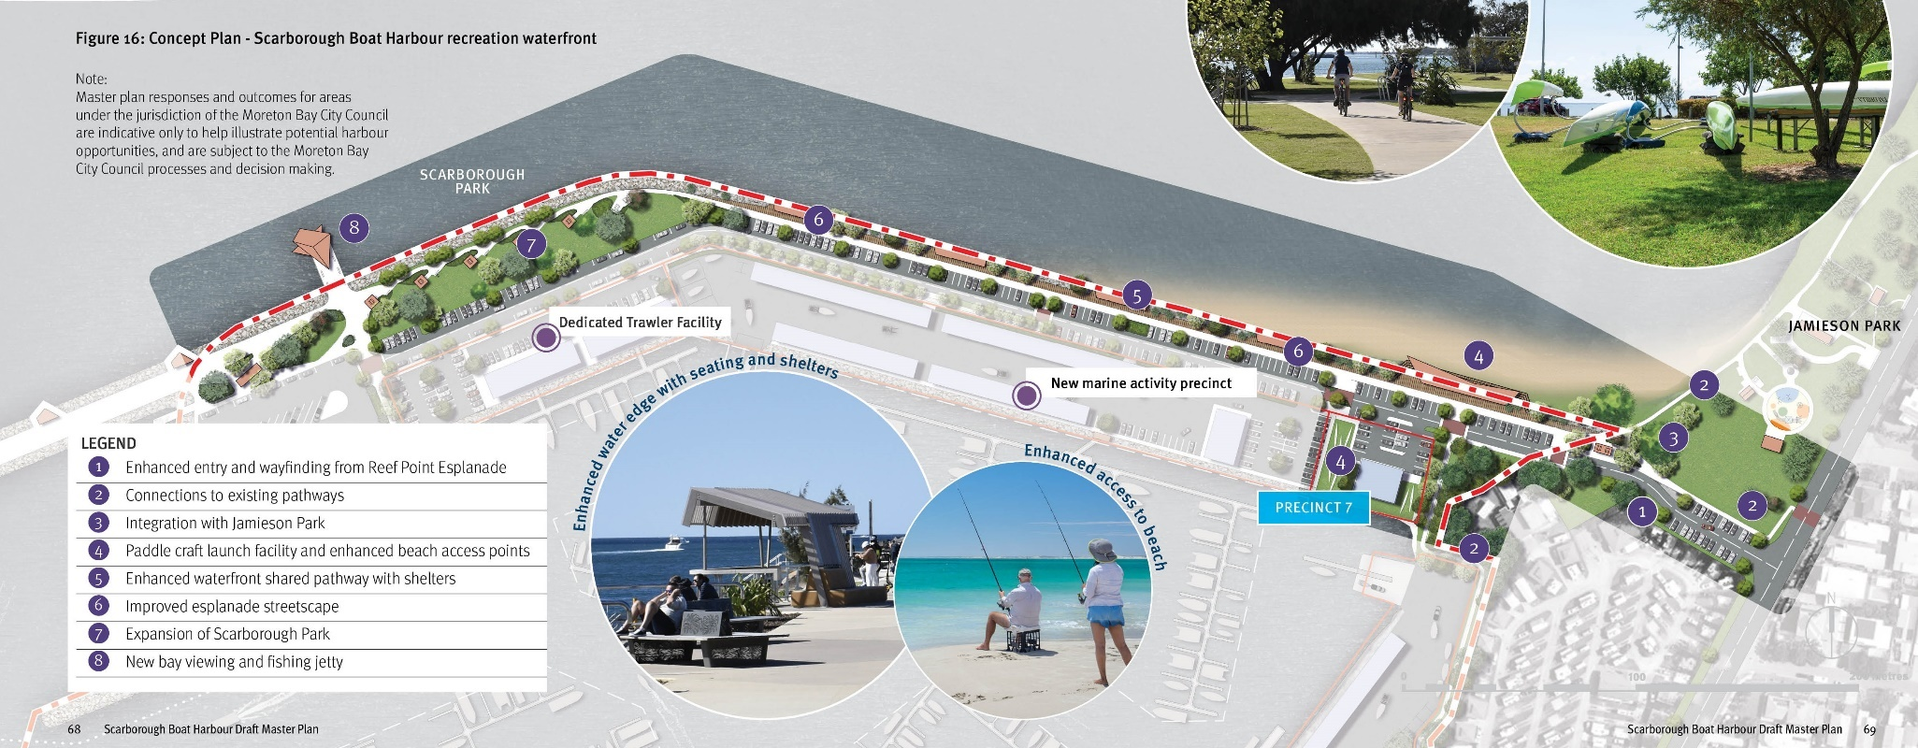

4 – Marine activity precincts
The harbour’s existing dry lease areas along Bird O’Passage Parade all have direct harbour frontage, enjoy good levels of public accessibility and have connections to Thurecht Park. There is an opportunity to prioritise this waterfront for low-impact marine and club related activities that draw value from these qualities, such as commercial marine activities, clubs or community organisations and recreation providers. Together with the mixed use entertainment precinct, these areas could establish a critical mass of public oriented businesses and activities at the harbour’s front door.

Key design and placemaking concepts
- Enhanced entry from Bird O’Passage Parade including streetscape improvements and clear wayfinding signage for visitors to the harbour (see 1)
- Improved Bird O’Passage Parade streetscape including formalised public on-street car parking, street trees and landscaping (see 2)
- Low intensity marine activity leases suitable for a wide range of marine-related leisure and recreation activities managed and operated by commercial businesses or community organisations (see 3 and 4)
- Enhancement of the shared walking and cycling path connection between Thurecht Park and Jamieson Park (see 5)
- Opportunity for a continuous public harbourfront walkway or boardwalk as an integrated outcome of future development proposals for dry lease precincts (see 6).
Image captions:
- Public promenade
- Boating clubs and entertainment
- Commercial marina opportunities
- Restaurant
- Caravan Park
- Tourism, commercial and entertainment activities.
Figure 17: Concept Plan - Marine activity precincts
Note: Master plan responses and outcomes for areas under the jurisdiction of the Moreton Bay City Council are indicative only to help illustrate potential harbour opportunities, and are subject to the Moreton Bay City Council processes and decision making.
LEGEND
- Enhanced harbour entry and wayfinding from Thurecht Parade
- Enhanced Bird O’Passage Parade streetscape
- Low impact marine and club activities
- Low impact marine activities
- Pedestrian/cycle connection
- Potential harbour front public access.

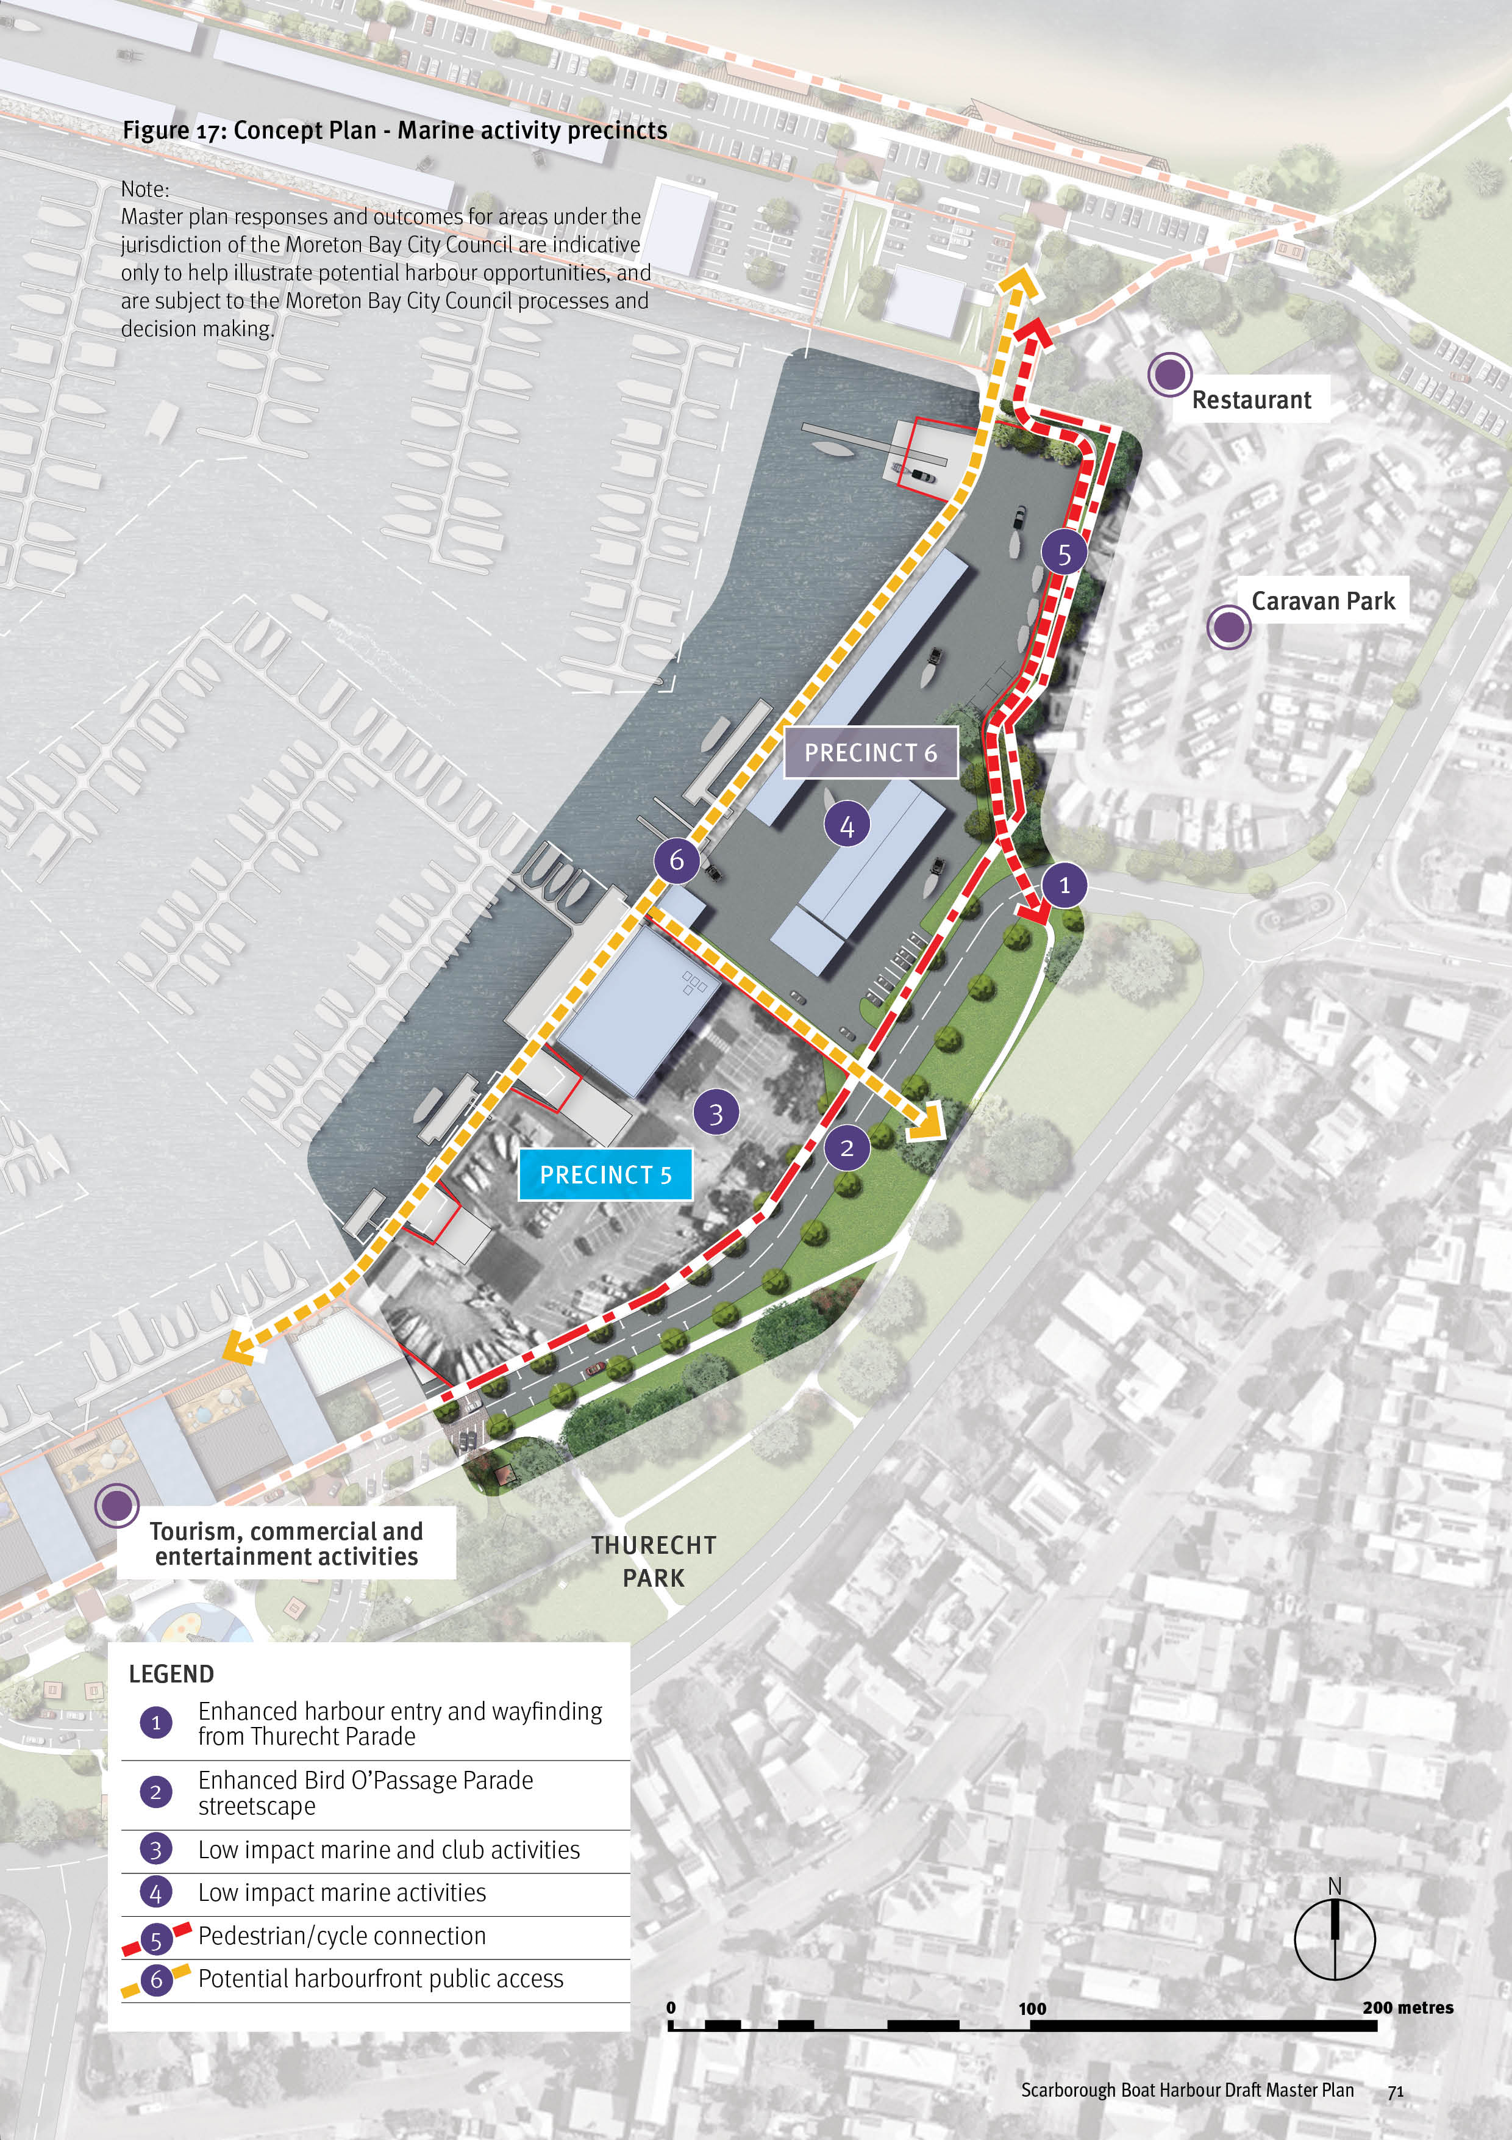

5 – Tourism, commercial and entertainment activities
The harbour’s centre of public life and activity will be the Tourism, Entertainment and Recreation Wharf. Building on the existing food and beverage offer, the goal is to facilitate the delivery of new buildings and an enhanced public realm that will attract a broad range of tourism and hospitality businesses to the harbour. The key amenity drivers of this transformation are its 200m harbour frontage, a dedicated wet lease for visitor and commercial berths, connection to Thurecht Park and high levels of public visibility and accessibility.

Key design and placemaking concepts
- Create a high quality tourism and recreation destination that elevates the harbour’s tourism role and entertainment functions through:
- high quality architecture and public realm design that draws value from the waterfront setting and reinforces a distinctive place character for the harbour
- a mixed use built form that supports an activated ground plane, establishes high quality settings for hospitality and entertainment businesses and offers floorspace for tourism operators or other organisations that can benefit from a harbour presence (see 1)
- a promenade or boardwalk establishing a fully public harbour’s edge (see 2)
- After alternative trawler facilities are available in the harbour, establish a dedicated wet lease for:
- recreational short term and day use berths
- tourism operators’ vessels and jetty facilities
- water taxis or ferries (see 3)
- In coordination with Moreton Bay City Council, strengthen the precinct’s relationships and connections with Thurecht Park addressing:
- Bird O’Passage Parade streetscape design prioritising pedestrians and providing additional landscape and tree planting, street furnishings and signage
- improvements and additions to Thurecht Park that complement the precinct
- dedicated bus setdowns for tourism operators
- appropriate levels of car parking for visitors that reduces impacts on the surrounding street network (see 4 and 5)
- Enhance the entry from Thurecht Parade including streetscape improvements and clear wayfinding signage for visitors to the harbour (see 6)
- Improve public transport infrastructure on Thurecht Parade with enhanced connections and wayfinding to the precinct (see 7).
Image captions:
- Potential Thurecht Park enhancements
- Vibrant tourism and recreation wharf
- Note: Master plan responses and outcomes for areas under the jurisdiction of the Moreton Bay City Council are indicative only to help illustrate potential harbour opportunities, and are subject to the Moreton Bay City Council processes and decision making.
Figure 18a: Indicative section through precinct
Image captions:
- Recreational short term mooring, day berths and tourism operator berths
- Public promenade
- Tourism, commercial and entertainment wharf with a ground level highly activated by commercial and retail activity
- Bird O’Passage Parade enhanced as an attractive, pedestrian prioritised streetscape
Figure 18b: Concept plan - Tourism, commercial and entertainment activities
LEGEND
- New mixed use building accommodating a range of tourism and hospitality businesses
- Public promenade to harbour
- Berths for recreational short term, day berths and commercial tourism operators
- Enhanced Bird O’Passage Parade streetscape and pedestrian prioritisation
- Enhancement of Thurecht Park and pedestrian integration with precinct
- Enhanced harbour entry and wayfinding from Thurecht Parade
- Improved public transport opportunities.

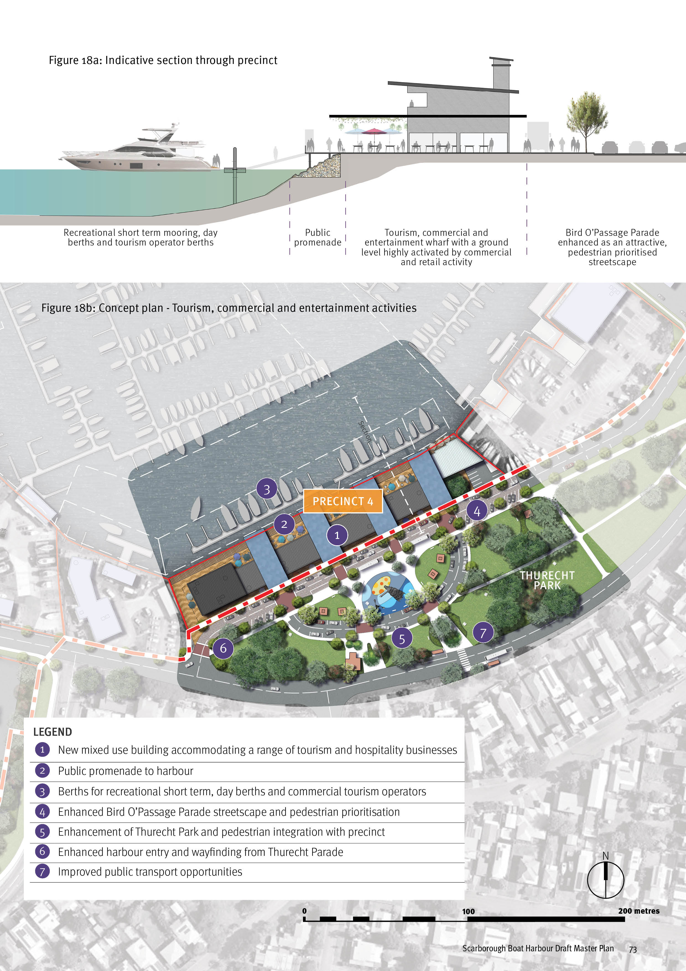

6 – Marine activities, low-impact marine activities, public boat ramp facility and government facilities
The harbour’s western arm consolidates commercial marine activities, leases for government and volunteer organisations and provides a major public boat ramp facility. The master plan intent is to protect these core functions and encourage the development of the vacant land for the expansion of low intensity commercial marine activities. A key public benefit will be a new walking and cycling path connecting to an enhanced park at the harbour’s mouth.

Key design and placemaking concepts
- Protection of existing marine activities and expansion of low impact/scale marine activity through the development of the underutilised boat harbour area (see 1), with appropriate landscape buffer/treatment to neighbouring housing on Oyster Point Esplanade (see 7)
- Retention of government services and volunteer organisations (see 2)
- Retention of the existing boat ramp and car/trailer parking (see 3)
- Maintain existing access via the extension of Thurecht Parade and improve the active transport function of the street (see 4)
- Enhance the park with additional shade planting, upgraded shelter and amenities to improve bay viewing opportunities (see 5)
- Enhance walking and cycling access to the harbour entry (see 6)
- Protect the existing stand of mangroves and providing a boardwalk or nature path connection from Oyster Point Esplanade to a new water’s edge pathway out to the harbour’s mouth (see 6)
Image captions:
- Enhanced water edge
- Retention of government services
- Additional maritime industry
Figure 19: Concept plan - Marine activities, low-impact marine activities, public boat ramp facility and government facilities
LEGEND
- Marine activities and low-impact marine activities
- Marine activities - low-impact
- Government services and volunteer organisations
- Existing boat ramp and car-trailer parking
- Improved Thurecht Parade extension road
- Enhanced park at harbour mouth
- Water’s edge walking/cycling pathway
- Mangrove conservation
- Buffer to residential properties
Image captions:
- Tourism, commercial and entertainment activities
- Low impact and scale of marine activities

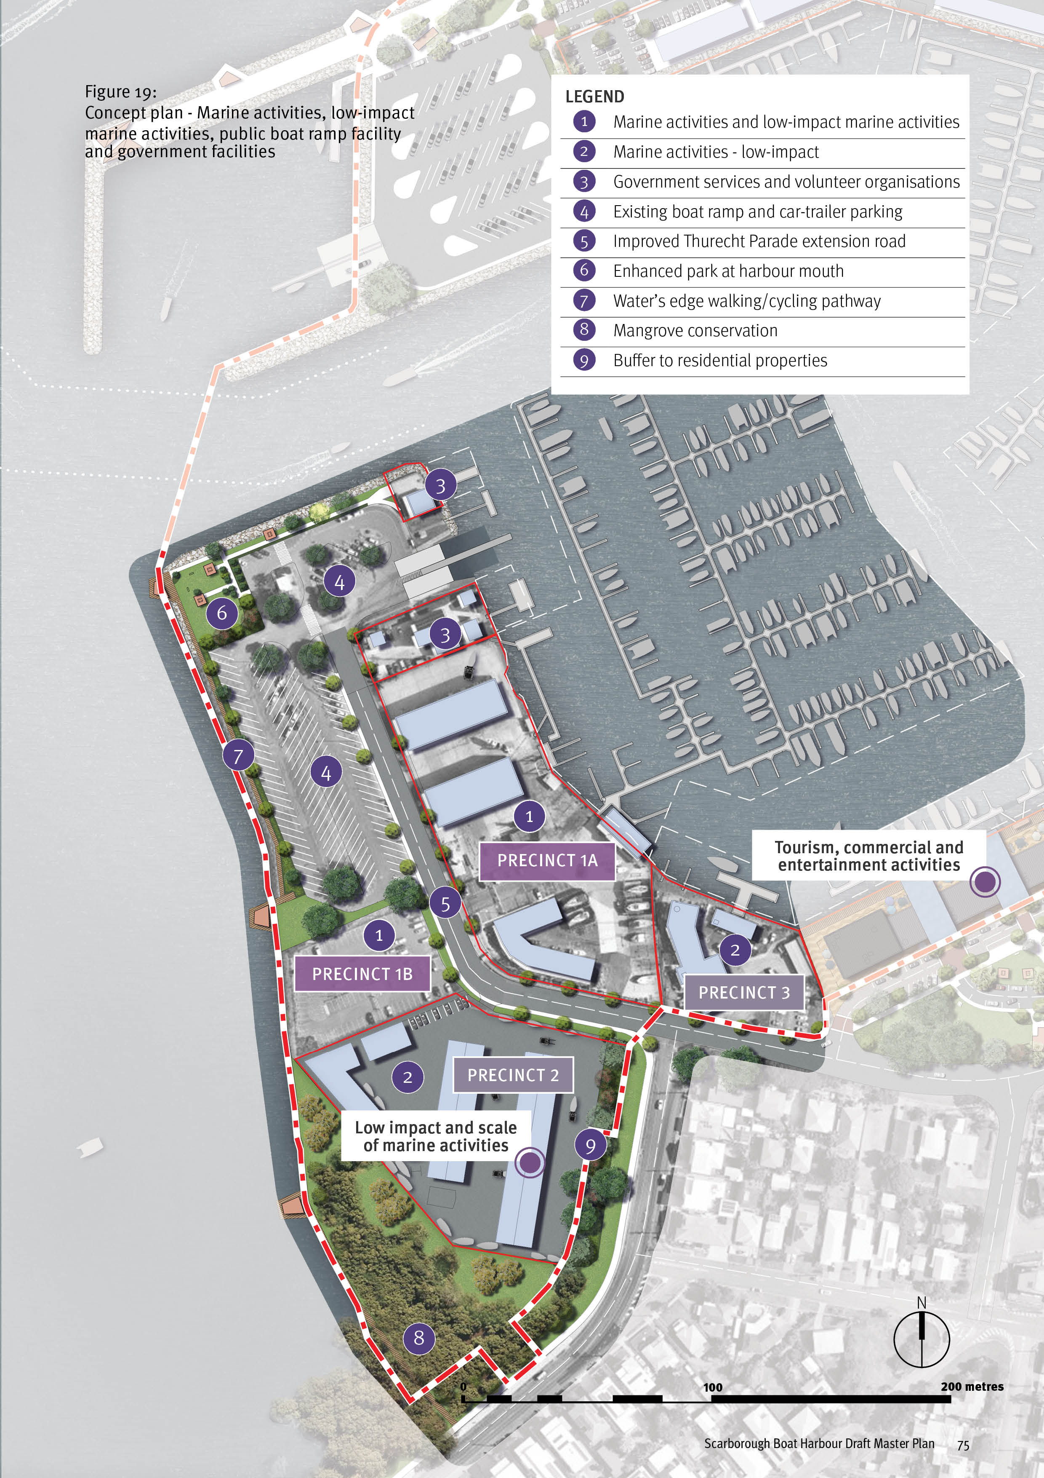

Implementation – Section 5

Implementation approach and initiatives
The master plan is a strategic and flexible document that will be used to guide decision-making and implementation actions over time.
The transition of Scarborough Boat Harbour towards the vision outlined in the master plan will be achieved through a combination of staged improvements and changes to existing infrastructure, and new development and leasing opportunities.
The following principles will underpin the implementation approach and initiatives:
- The master plan works within the existing legislative and leasing frameworks relevant to the harbour
- Existing lease arrangements will not be affected by the master plan
- Working agreements and / or governance arrangements will be established with the Moreton Bay City Council to promote collaboration and master plan outcomes
- The master plan will guide decision making for future development and leasing opportunities
- Master plan outcomes and initiatives will be utilised to inform existing infrastructure planning and prioritisation programs
- The master plan will be updated, monitored and reviewed over time.
STRATEGIES

Strategy 1 – Strategic Positioning and Regional Profile
IMPLEMENTATION INITIATIVES | TIMEFRAME
Investigate and promote the expansion and development of a mixed-use harbour front area capable of accommodating a broad range of marine tourism, entertainment and recreation businesses that elevate the tourism profile and function of the harbour including:  - engagement with Council, state agencies to identify initiatives and opportunities;  - investigate private sector investment opportunities in tourism products and event /experience infrastructure. | Short - medium term
Investigate branding and marketing options that position the harbour as a state-significant asset and raises business and community awareness of commercial and recreation opportunities. | Medium – long term
In recognition of the harbours strategic location and proximity to trawl fishery, engage with tenants, industry bodies and stakeholders to identify ways to promote the harbour, understand and meet infrastructure demand, and establish contemporary processes that address emerging trends in the maritime industry. | Ongoing

Strategy 2 – Harbour Function and Operations
IMPLEMENTATION INITIATIVES | TIMEFRAME
Where required, undertake detailed technical investigations and background monitoring consistent with Queensland legislative and regulatory requirements. Anticipated elements include:  - coastal processes and environmental values  - marine infrastructure and ground investigations  - cultural heritage and tenure and title | Short - medium term
Collaborate with harbour tenants to ensure a sustainable strategy is in place for the management of dredge spoil, consistent with relevant state policy and Queensland legislative requirements. | Short - medium term
Investigate opportunities to consolidate government functions to maximise the efficient use of available land within the harbour. | Short - medium term
Engagement with industry and relevant stakeholders to understand infrastructure demands and emerging trends in the maritime industry. | Ongoing
Retain trawler facilities at their current location and boat ramp capacity in the harbour until alternative locations / facilities are available. | Ongoing

Strategy 3 – Environment
IMPLEMENTATION INITIATIVES | TIMEFRAME
Where required, undertake detailed technical investigations and background monitoring consistent with Queensland legislative and regulatory requirements. Anticipated elements include:  - coastal processes and environmental values  - marine infrastructure and ground investigations  - cultural heritage and tenure and title | Short - medium term
Encourage private sector investment in new developments that seek to incorporate environmentally sustainable practices and align with current and emerging environmental and coastal development standards | Ongoing
Collaborate with and encourage tenants to incorporate environmentally sustainable practices, consistent with environmental standards and legislation. | Ongoing
Incorporate environmentally sustainable practices and innovative approaches in the delivery of state public marine infrastructure and encourage opportunities to support the transition to 'net zero'. | Ongoing
Identify opportunities to embed education on sustainable practices and awareness of ecological values in harbour planning and design and ongoing harbour operations that complements the harbours proximity to Moreton Bay Marine Park. | Medium

Strategy 4 – Connecting to Scarborough
IMPLEMENTATION INITIATIVES | TIMEFRAME
Coordinate with state and local government stakeholders to develop a movement network and car parking strategy addressing:  - public transport  - active transport  - private vehicles and car parking (including public and private parking)  - recreation boat traffic and car-trailer parking  - service and commercial vehicles  - Northern Moreton Bay Tourist Drive. | Short - medium term
Prepare a public access, signage and wayfinding strategy for the harbour that links to the surrounding area and other important local nodes, including creating a clear sense of arrival to the working harbour. | Short - medium term

Strategy 5 – Place Character and Activation
IMPLEMENTATION INITIATIVES | TIMEFRAME
Engage with the Traditional Owners of Scarborough and Moreton Bay to identify opportunities to embed cultural history and meaning in harbour planning and design and ongoing harbour operations. | Ongoing
Prepare a harbour public realm concept plan in consultation with the Moreton Bay City Council and leaseholders, that incorporates the movement network and car parking strategy, public access, signage and wayfinding strategy, and comprehensively addresses:  - public realm character and design quality  - accessibility, safety and wayfinding  - open space function and character  - streetscapes and car parking  - integration of adjacent parks, connecting streets and active travel networks  - public transport infrastructure  Establish a program of works aligned to outcomes of the public realm concept plan and integrate within existing infrastructure planning, prioritisation and funding frameworks. | Short - medium term

